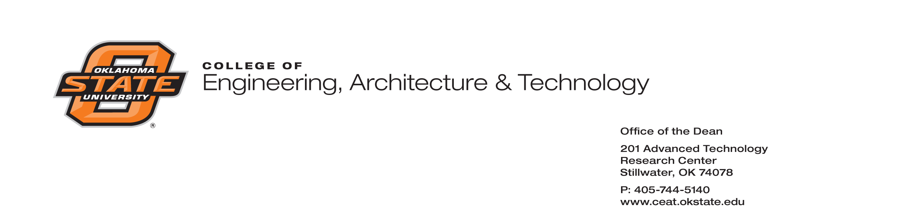**AGENDA**

**OKLAHOMA TRANSPORTATION CENTER**

**JANUARY 30, 2014**

**206 ATRC, Oklahoma State University, Stillwater, OK**

**2PM**

1. Call to Order
2. Compliance to Open Meeting Law
3. New MOU for OkTC (Bowman)
4. ODOT Research and Implementation Proposal Process for SPR Funds for ODOT specific needs – (Outside of Southern Plains Transportation Center matching funds).
5. Report on Final close out of National University Transportation Center under SAFTEA-LU (Suzette Lavoie)
6. Report on closure of office in Midwest City. (Tikalsky)
7. Report on start-up of SPTC (Musharraf Zaman and Kelvin Wang)
8. Other Business
9. Adjournment