
Open House Hits Record Attendance  More than 1,250 people attended Open House on Saturday, April 2, from 9 a.m. to 4 p.m. That's the highest attendance ever recorded for this event. Participants enjoyed many live animal demonstrations, a variety of exhibits and fun activities. The silent auction raised $1,142 for the Avian, Exotics and Zoo Medicine Service. View Open House 2016, a short video to see some of the highlights.  Special thanks to Anna Teague, admissions coordinator, and the Open House Committee: Kara Reinhart, chair, Zach Croslin, assistant chair, and committee chairs Ashley Chandler, Elise Durville, Bayley Fuller, Kate Gault, Sarah George, Kaitlyn Gregg, Mackenzie Jochim, Kelsey Ledbetter, Sarah Myers, Jeff Olivarez, Stasha Ryland, Rachael Scott, Alexis Sirois, Cameron Smithee, Courtney Tewary, Nick Thompson, Christine Toffoli, and Kelsey Walker. View a complete list of Open House Committee members.  Pacemaker Posse Reunites  During Open House, Dr. Ryan Baumwart, veterinary cardiologist, and the OSU Foundation co-hosted the first Pacemaker Posse Reunion. The Pacemaker Posse consists of 21 dogs that have undergone a pacemaker placement surgery performed by Dr. Baumwart. Five dogs and their owners were able to travel to Stillwater on Saturday, April 2, for this inaugural reunion.  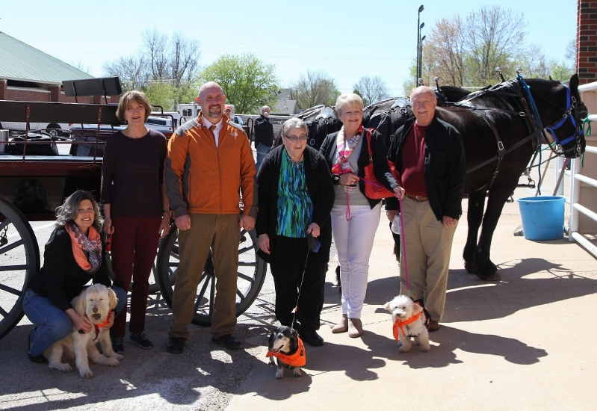  Pictured left to right are: Brandy Hutchings, veterinary assistant, with Percy owned by Rebecca Dees, Dr. Ryan Baumwart, Mary Jo Wipperfurth with Snoopy and Susie and Kenneth Sharp with Gigi. Also attending but not pictured were Patricia Wayman with Abby and Maureen Cancienne with Sassy.  Student Activities  VDI will meet today, April 11, at 12 p.m. Dr. Corey Wall will discuss tips on when to use MRI versus CT.  A blood drive will be held today, April 11, from 1:30 p.m. to 7:30 p.m. in the Old Phys Room 152. | Veterinary Biomedical Sciences PhD Defense Seminar  Katie Smith, DVM, will present "Advancements in the Medical Treatment of Fungal Keratitis in Horses" on Tuesday, April 12, at 12 p.m. in Room 104 at the Veterinary Medical Hospital. Smith is a PhD candidate and an ophthalmology resident. She is mentored by Dr. Margi Gilmour.  Oklahoma Center for Respiratory and Infectious Diseases Seminar  Susan Marie Majka, PhD, will present "Perspectives of Lung Mesenchymal Stem Cells During Tissue Repair versus Disease" on Wednesday, April 13, at 12:15 p.m. in Room 259 McElroy Hall. Majka is an associate professor in the Department of Medicine at Vanderbilt University. This seminar is co-hosted by OCRID and the Interdisciplinary Program in Regenerative Medicine at OSU.  House Officer Seminars  Two presentations will be made on Thursday, April 14, beginning at 8 a.m. in Room 104 at the Veterinary Medical Hospital.  Amy Bertelli, DVM, will present "Post Breeding Endometritis in the Mare." She is a theriogenology intern mentored by ​Dr. Betsy Coffman.  Allison Wilson, DVM, will present "Bartonella spp. in Companion Animals. She is a small animal internal medicine specialty intern mentored by ​Dr. Laura Nafe.  Veterinary Biomedical Sciences Seminar  Kacey Cliburn, MS, will present "Postmortem distribution of THC and related cannabinoids" on Thursday, April 14, at 4 p.m. in Room 259 McElroy Hall. Cliburn is a research toxicologist and PhD student from the FAA-Civil Aerospace Medical Institute in Oklahoma City. Cliburn is mentored by ​Drs. Jarrad Wagner ​and ​Lara Maxwell.  Coming Attraction  The award-winning documentary, Nature vs Nature: The Animal Victims of the May 2013 Oklahoma Tornadoes," will be showing on Tuesday, April 26, at the Stillwater Public Library beginning at 6:30 p.m. In the film you will see some of the animals treated at OSU's Veterinary Medical Hospital as well as the many faculty, staff, students and alumni who helped in the recovery efforts. Mark your calendar to attend.




