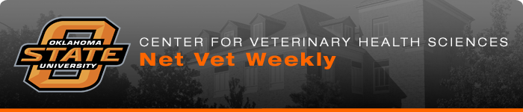
Congratulations, Class of 2016!  There are 88 new OSU Cowboy veterinarians ready to make a difference in the lives of their patients, their clients and the world. We wish them much success as they each select a career path that suits them best.  Last week we featured Kimberlee Lenaburg. Here are links to a few more short stories and some videos from the Class of 2016:  - Paul Cunningham the Dean McElroy Award Recipient  - Kaitlin Agel, Mandy Hall and Cyrena Neill are Dual Degree Pioneers  - Alex Portanova on a Kansas City Zoo Externship  - Andrew Willis carries on a Family Legacy.  Class of 1966 Celebrates 50th Reunion  The Class of 1966 reunited in Stillwater to celebrate their 50th class reunion. Special thanks to Sharon Worrell, alumni affairs specialist, and class representative Dr. Jack Roberson on making this reunion one to remember.  Publication  Rudd JM, Ashar HK, Chow VT and Teluguakula N. (2016) Lethal Synergism between Influenza and Streptococcus pneumoniae. J Infect Pulm Dis 2(2): doi https://sciforschenonline.org/journals/pulmonary-diseases/JIPD-2-114.php.  Thank You, Nationwide  The Veterinary Business Management Association at the veterinary center recently hosted Dr. Carol McConnell, Nationwide's Chief Veterinary Medical Officer.  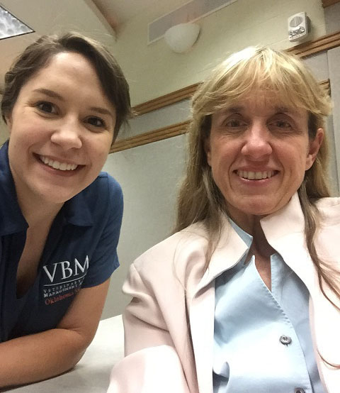  Left to right Kaitlyn Belanger ('18), VBMA co-president, with Carol McConnell, DVM, MBA.  Nationwide treated veterinary students and area practitioners to an educational dinner meeting. McConnell talked about wellness plans and the benefits of pet insurance for small animal practices. | Ross to Serve as Interim Dean  The Provost recently announced that Dr. Chris Ross, associate dean for academic affairs, would serve as interim dean at the Center for Veterinary Health Sciences. Earlier this year Dr. Jean Sander announced that she would be leaving Oklahoma State University and the veterinary center to accompany her husband as he makes a career move. A search committee for a new dean will be formed in the near future.  Poudel Receives Graduate Fellowship  Congratulations to Nabin Poudel on receiving the Otto S. Cox Graduate Fellowship for Genetics Research! Poudel, a graduate teaching assistant in Dr. Myron Hinsdale's lab in the Department of Physiological Sciences, was awarded the fellowship for his research on human patients with Spondylo Ocular Syndrome. There is a limited number of these competitive $1,000 Fellowships.  Recently Poudel's team published this paper identifying mutations in XYLT2 Spondylo Ocular Syndrome. Spondylo Ocular Syndrome is a rare genetic condition in humans involving developmental defects in the eye and the spine.  Tornado Documentary Showing  The award-winning documentary, "Nature vs Nature: The Animal Victims of the May 2013 Oklahoma Tornadoes" will be shown on Tuesday, May 10, at 6:30 p.m. at the Stillwater Library. In the film, you will see some of the animals treated at the Veterinary Medical Hospital as well as many of the faculty, staff, students and alumni who helped in the recovery efforts. There is no charge to attend.  House Officer Seminar  Dr. Brandon Gates will present "Embryo Transfer" on Thursday, May 12, at 8 a.m. in Room 104 at the Veterinary Medical Hospital. Gates is a theriogenology resident mentored by Dr. Betsy Coffman.  OSU/OVMA Summer Seminar  The OSU/OVMA Summer Seminar will be held on June 17 and 18 in McElroy Hall. Registration is available now online. For complete details about the schedule, speakers and to register, visit OSU OVMA Summer Seminar now.  Dr. Wiley Recognized  Katherine and Edwin Sain of Oklahoma City recently honored their veterinarian, Dr. Michael Wiley of Norman, Okla., in the best possible way. They established a scholarship in his name to help ensure that future large animal veterinarians will be available when the need arises read more.




