THE OKLAHOMAN
Tuesday, December 5, 2005

Light dome becomes OSU’s bright, new research project
By David Zizzo Staff Writer
David Zizzo: 475-3233, dzizzo@oklahoman.com

STILLWATER — When Thomas Gedra mentioned he was wiring 342 standard light bulbs in one room — with the capacity to use enough electricity to run 15 space heaters — a friend figured he was planning for the holidays.
“He’s like, ‘Well, Tom, besides cooking turkeys, what are you going to do with all that light?’” said Gedra, an associate professor of electrical engineering at Oklahoma State University.
The project inside a windowless room in the Advanced Technology Research Center has to do with Khaled Mansy’s idea to have dominion over the sky and the sun — at least in the 14-foot world he, Gedra and three others are working on. Mansy, an architectural engineering professor, Gedra and their colleagues at OSU are building a daylight laboratory that someday could help reduce energy used to light buildings.
“When you design a building, you want to really use the daylight,” Mansy said. “You can save lots of energy, especially in commercial buildings.”
Others involved in the project are Steven O’Hara, architectural engineering professor; Qamar Arsalan, an electrical engineering doctoral candidate; and Aaron Lewis, an architectural engineering student.
The lab is expected to be completed next summer. It will consist of a dome 14 feet in diameter made of translucent plastic surrounded by a concentric dome-shaped metal framework wired with 341 light sockets. Each will hold a standard 75-watt bulb that can be dimmed with electronic controllers, Mansy said. That will allow researchers to simulate sky lighting conditions for any time of day, any season and any weather condition.
Gedra considered using lighting that was more exotic, such as LEDs, but the popularity of that technology has kept demand and prices too high for a project on a budget, he said. “Right now it’s kind of froufrou lighting.”
Inside the dome, the researchers will mount a 150-watt “sun” that can be moved to any position, making the equipment rare among lighting labs. “The good thing about this lab is it can simulate both the sun and the sky at the same time,” Mansy said. Architectural students and researchers will place scale models of homes, buildings and other structures inside the translucent inner dome to test the effect of natural light on their designs and proposed orientation. Models will be built on a 1 /24th scale, meaning 1 /2 inch of the model will equal one foot of an actual building.
Although the lights have the capacity to consume 26 kilowatts of electricity, they might never all be switched on at the same time at full brightness, Gedra said. Also, taking light readings with sensors placed in or around the model buildings takes only an instant, so the lights might be on only seconds at a time.
The project, funded with $85,000 from the National Science Foundation and $37,000 from OSU, is aimed at reducing one of the biggest uses of energy — lighting of buildings, Mansy said. Lighting in buildings in America uses 10 percent of all energy used in the world. Lighting accounts for more than half of all energy used in U.S. public schools, Mansy said.
“That’s a huge percentage,” he said.
So if architects can design buildings that make better use of natural light, Mansy said, energy savings can be huge. Besides, he said, natural light is just better. The “cool” light from outdoors adds less heat in the summer than interior lighting, and it has a higher efficacy.
In engineering language, that means number of lumens per watt of daylight is higher, twice that of a florescent lamp and ten times that of an incandescent lamp, according to ArchitectureWeek magazine. For most of us, that just means sunlight is nicer, brighter and more effective. Not to mention free.
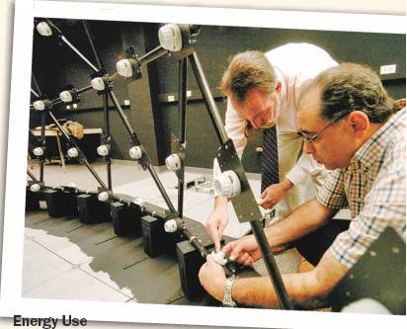
BY MATT STRASEN, THE OKLAHOMAN
OSU electrical engineering professor Thomas Gedra, left, and architectural engineering professor Khaled Mansy discuss installing lights in the daylight laboratory dome.

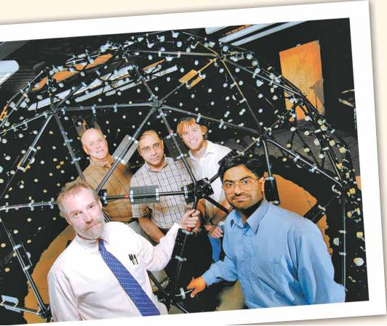
Working on the daylight laboratory dome at OSU are, front row from left, professor Thomas Gedra and doctoral candidate Qamar H. Arsalan and, back row from left, professors Steven O’Hara and Khalad Mansy and engineering student Aaron Lewis.
BY MATT STRASEN,
THE OKLAHOMAN PHOTO ILLUSTRATION BY JENNIFER ARMSTRONG, OKLAHOMAN GRAPHICS

