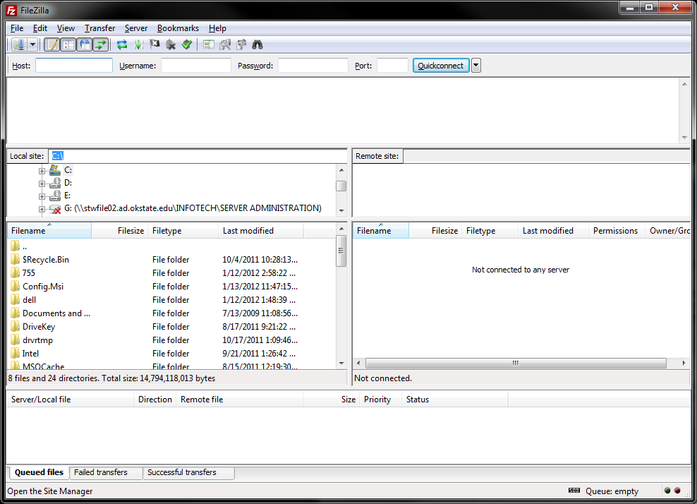
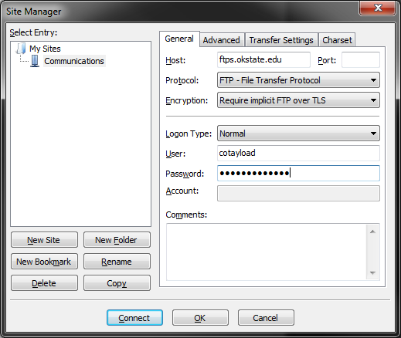
FileZilla works both on and off campus to connect to ftps.okstate.edu. To download FileZilla, visit http://filezilla-project.org/download.php?type=client and choose the correct computer file you need. To setup a new connection, open the “Site Manager” by clicking on the icon circled in red. Site Manager may also be accessed by clicking on File->Site Manager.

Under Site Manager, click the “New Site” button. FileZilla will create a new site in the left hand pane. You may name the site anything you like.
Under the “General” tab make the following changes:
- Host: ftps.okstate.edu
- Protocol: FTP – File Transfer Protocol
- Encryption: Require implicit FTP over TLS
- Logon Type: Normal
- User: Enter in your OKEY username or the name of the Service Account that is to be used with the site. Media username is osuftp
- Password: The OKEY password associated with the previously entered account. Media password is GoPokes1890
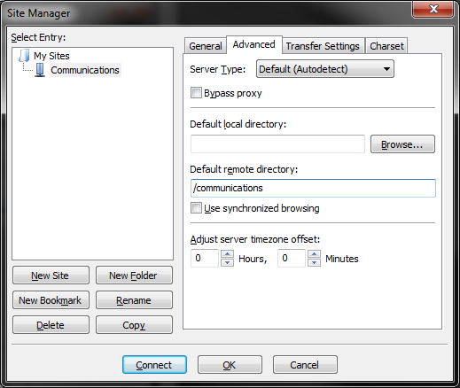
Under the “Advanced” tab, make the following changes:
- Default Remote Directory: /communications
Under the “Transfer Settings” tab, make sure that “Default” is selected as the transfer mode.
Click connect, and you should be able to access the Communications site on ftps.okstate.edu

