

December 4, 2009

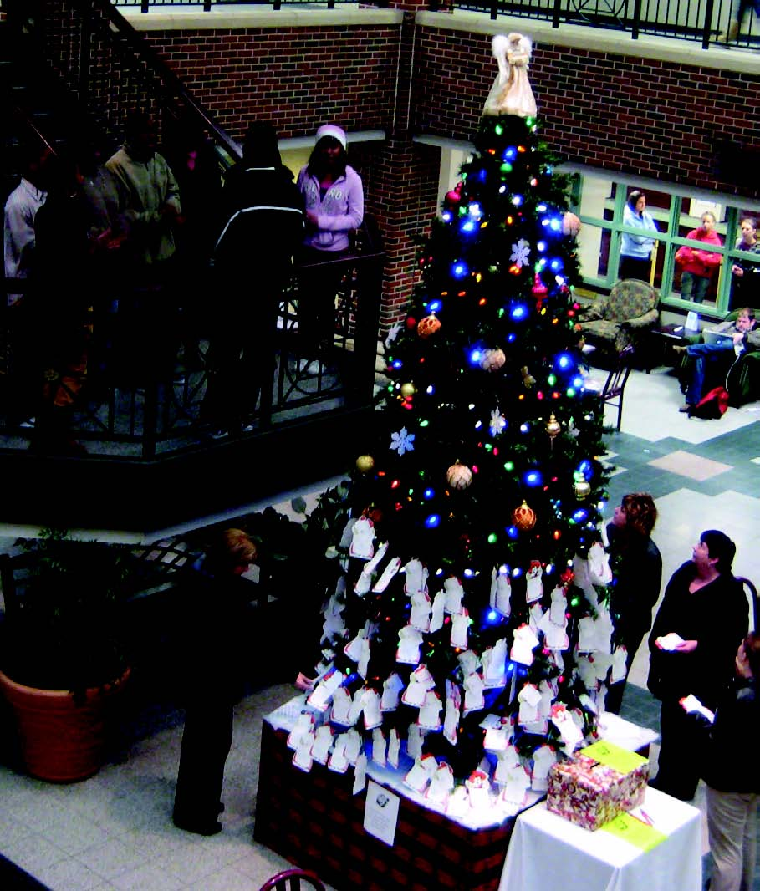
Oklahoma State University’s campuses are showing the holiday spirit. Above, a beautiful sea of poinsettias are being grown and readied for sale by the OSU-OKC Horticulture Department. On the left, the unveiling of the Angel Tree in the Student Union Atrium and the music of the Burnin’ Black Gospel Choir are an annual event of the Non-Traditional Student Organization. People select angels from the tree, purchase the listed gifts, and return them so that the gifts can be distributed to families in need in Stillwater. On the right, OSU Center for Health Sciences receptionist Ebony Brown shows off the student lounge mascot, Big Dog, who wears a wreath of greenery, a bow and orange accents for the holidays.
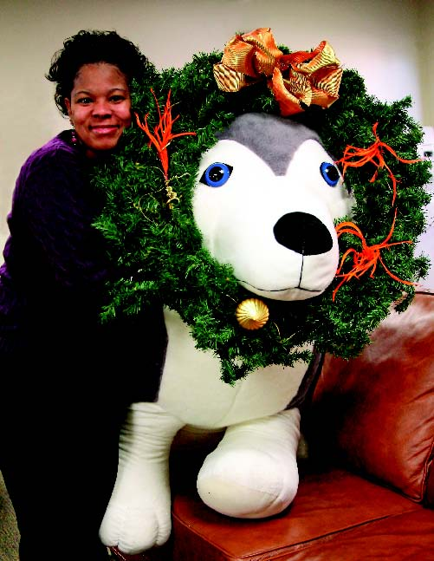

International Graduate Enrollment Increases
OSU is experiencing a higher enrollment of international graduate students this fall compared to the national average, according to reports released by the Council of Graduate Schools in Washington, D.C.
Nationwide, offers of admission for international applicants to U.S. graduate schools decreased slightly from 2008, the first
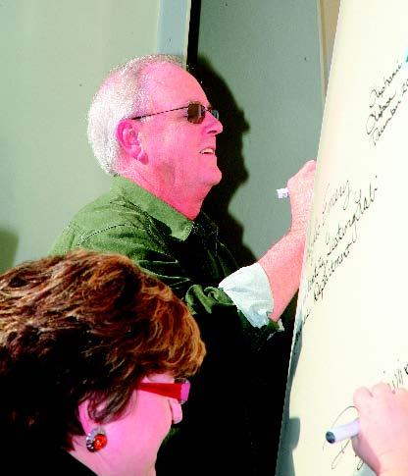
A topping-out ceremony marked progress for a new building for OSU-CHS Forensic Sciences and the Tulsa Police Department Forensic Laboratory and Property Room. Rob Allen, professor and chair of forensic sci-ences, top, and Dana Livingston, director of Student Affairs, joined faculty, staff, students and guests in signing strobic fan toppers before the toppers were lifted to the top of the building. The 160,000 square-foot building
has five floors.
decline since 2004. The number of new international graduate student enrollments stayed roughly the same, causing the
first-time enrollment to flat-line across the
country.
At OSU, the trend was more positive. According to Gordon Emslie, OSU Graduate College dean, although offers of admission to OSU were lower in 2009, the first-time enrollment of international graduate students actually jumped nearly 12 percent, from 305 students to 341 students. This brought the total international graduate student enrollment to 1,341 this fall, an increase of 8.58 percent over last year.
“International graduate student enrollment is at a six-year high for OSU,” he said. “While the number of admission offers is a good indication of the strength of an applicant pool, it is the number of new enrollments that provides the best indicator of the attractiveness of an institution’s programs to prospective students.”
Emslie believes graduate enrollment is up in part because OSU has made a concerted effort over the last five years to increase awareness of OSU’s graduate programs, and he cited not only the increase in numbers but also the quality of the graduate students who enroll.
India has the most international graduate students on the OSU campus, comprising 521 of the 1,341 international graduate students.
OSU, OSUIT Schedule Commencements
Stillwater
OSU alumnus Rick Darnaby of Montecito, Calif., who has led a number of high-tech global businesses and is known for his innovative leadership style, will be the speaker for the OSU commencement on Dec. 12 in Stillwater.
Darnaby holds a B.S. in business administration, ’78, and an M.B.A.,
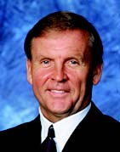
Darnaby
’79, from OSU. He has served as president for the NutraSweet Company, president and general manager for Motorola Company in Europe, as well as president and CEO of Monsanto Canada, Inc., among others.
He is currently the managing partner
of three Conceptual Age consulting firms
serving high technology industries.
Okmulgee
More than 160 OSUIT students will receive their degrees during a fall graduation ceremony on Dec. 15 at 7:30 p.m. in Covelle Hall.
The guest speaker will be Nevyle R. Cable, president and chief executive officer of the First National Bank and Trust Company of Okmulgee.
The student response
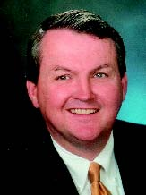
Cable
speaker will be Dorothy Mwakina, who will receive her associate in applied science in orthotics and prosthetics.
Members of the Board of Regents for Oklahoma State University and the A&M Colleges will con
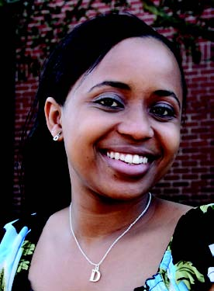
Mwakina
gratulate the graduates.
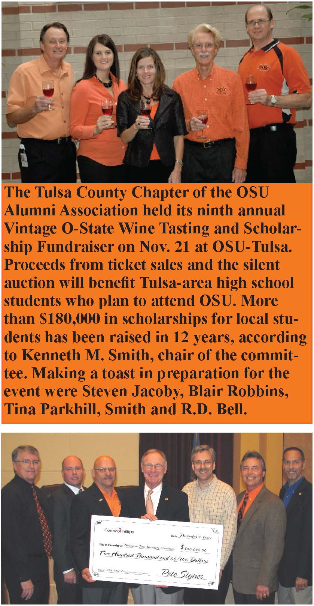
David Myers, Ponca City Development Authority; Web Keogh, University Multispectral Laboratories; Ponca City Mayor Homer Nicholson; OSU President Burns
Hargis; ConocoPhillips Refinery Manager
Pete Stynes; PCDA Chair Lee Evans; Rep. Ken Luttrell and Sen. David Myers took part in the ceremony in which the fourth
and final $500,000 installment check from
ConocoPhillips and the PCDA was presented to the UML. The UML has already pumped more than $24 million into the Ponca City economy in the three years it’s been operating, according to Myers.
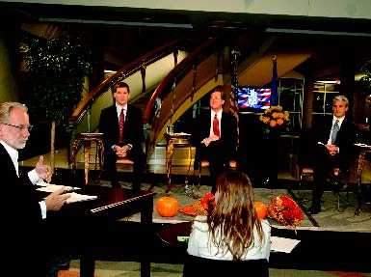
A 2009 mayoral forum was broadcast live from OSU-Tulsa’s Helmerich Advanced Technology Research Center on Oct. 27 featuring candidates Mark Perkins, Dewey Bartlett and Tom Adelson. Viewers submitted questions online for the candidates. The forum was presented by the Tulsa World, Cox Communications, OSU-Tulsa and the League of Women Voters.

Biofuels Development Receives $4.2 Million Grant
OSU-OKC Nursing Skills

Ray Huhnke shows how a biobased economy with “green” renew-able energy crops will enhance current fossil fuel technologies.
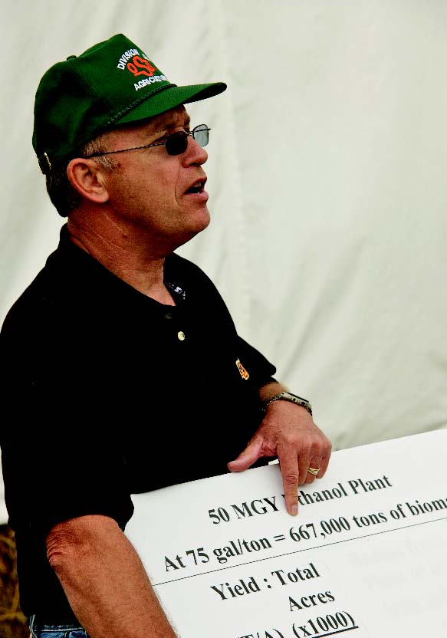

OSU and its partner institutions in industry are receiving $4.2 million from the U.S. Department of Agriculture to continue groundbreaking work in the development of biofuels, according to Ray Huhnke, biosystems and agri cultural engineering professor and director of the OSU Division of Agricultural Sciences and Natural Resources Bio-based Products and Energy Center.
Huhnke said the visibility of the Oklahoma Bioenergy Center and the established partnerships between OSU, OU
and the Samuel Roberts Noble Foundation,
played a key role in securing the federal funding.
OSUIT and Richland Partner on Degree Program
OSUIT’s Information Technologies Division formalized a partnership to allow information technology students from Dallas-based Richland College to transfer into OSUIT’s information assurance and forensics program.
Students completing the associate in applied science in digital forensics degree at Richland will be able to transfer up to 63 credit hours into the OSUIT bachelor of technology in information assurance and forensics degree program.
OSUIT’s President Bob Klabenes and Information Technologies Division Chair Scott Newman met with acting Richland President Kay Eggleston and Martha Hogan, executive dean of Richland’s School of Engineering, Business and Technology,
for the official signing of the agreement.
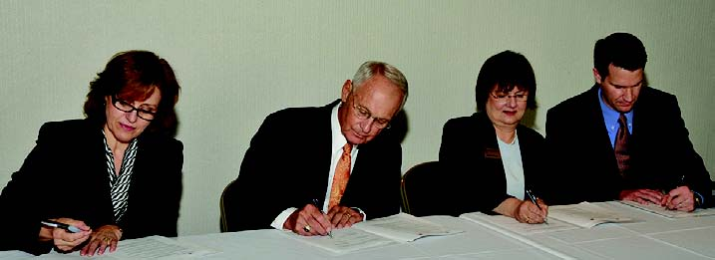
Signing the agreement are Kay Eggleston, Richland College acting president; Bob Klabenes, OSUIT president; Martha Hogan, executive dean of Richland’s School of Engineering, Business and Technology; and Scott Newman, OSUIT’s Information Technologies Division chair.
“The $4.2 million grant and the presence of the Abengoa plant are indicators of how OSU and our cooperating partners are particularly well-positioned to take a lead role in helping the United States become a viable biobased economy, and in ensuring that Oklahoma plays a particularly key role,” said Robert E. Whitson, OSU dean, division director and vice president of agricultural programs.
A record attendance for a Pickens Town Hall was set on Oct. 29 when T. Boone Pickens came to Gallager-Iba Arena to discuss his national movement toward a new energy future.
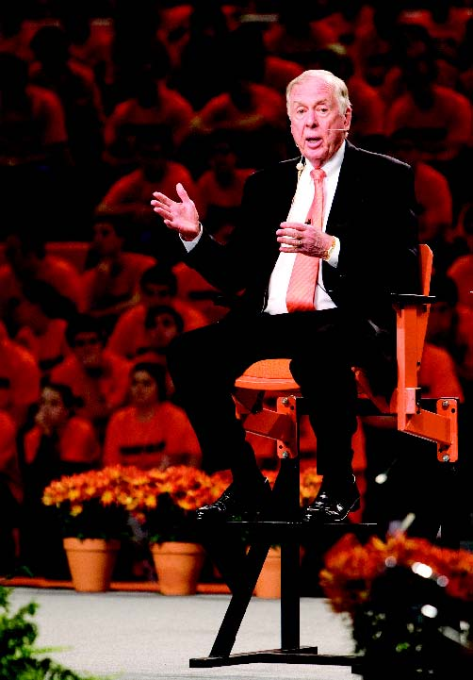
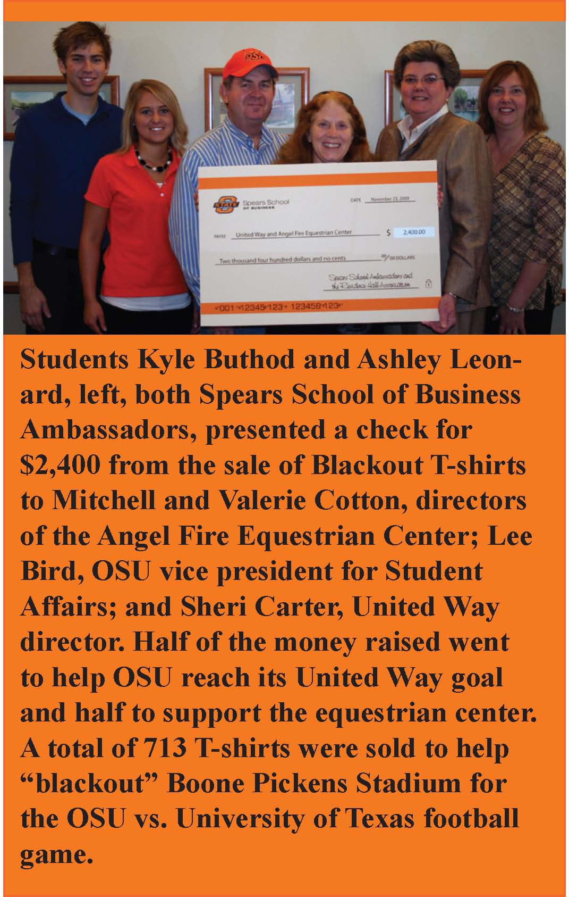
Lab Awarded Inasmuch Grant
The OSU-Oklahoma City Nursing
Department and the Development Office
were recently
notified that a
$100,000 grant
application for
equipment/
technical sup
port upgrades
to the
OSU-OKC
Nursing Skills
laboratory has
been selected
for funding
from the
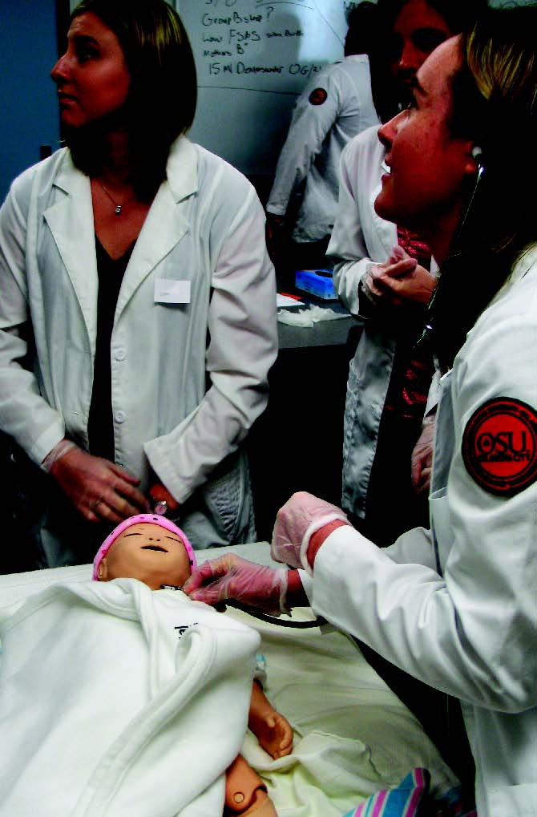
Inasmuch Foundation.
The upgrades will allow nursing students to experience real-life clinical situations in the skills lab and better prepare them for hospital clinical performance. These upgrades to the R.N. program will also help OSU-OKC to move quickly to meet the increasingly critical shortage of well-trained R.N.s in Oklahoma.
NSF Grant Awarded To Study Lake Ecosystems
Puni Jeyasingh, OSU zoology assistant professor, and Lawrence Weider, OU zoology professor, received a $780,000 grant from the National Science Foundation to examine the effects of long-term pollution on lake ecosystems and how it impacts the livelihood of organisms that inhabit them. OSU received $414,000 of the grant.
The two investigators will examine how aquatic organisms cope with drastically altered environments caused by nutrient pollution. The study, the first of its type, has targeted lakes in Canada and Minnesota where eggs have laid dormant for more than 50 years. The researchers will compare how phosphorus affects today’s aquatic life vs. that of 50 years ago.
“In the last 50 years, the amount of phosphorus going into lakes has increased 100-fold and we want to find out how these animals are coping,” Jeyasingh said.
Jeyasingh
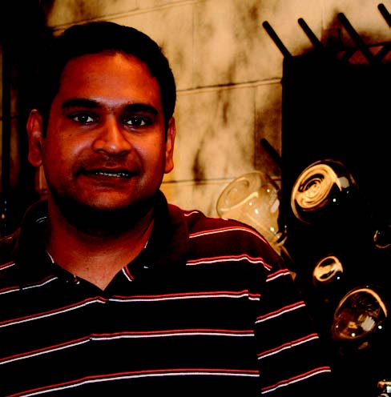

OSU
’
s Alumni Association honored the

Seniors of Significance, students who have
excelled in scholarship, leadership and service for the OSU campus and Stillwater community on Nov. 23. They represent approximately the top one percent of the 2009-10 graduating class.
This year’s honorees are: Kyle Andrews, Tulsa, finance; Austin Beerwinkle, Hydro, mechanical and aerospace engineering; Stacey Brandhorst, Weatherford, journalism; Brady Brewer, Hunter, agricultural economics and accounting; Janea Butler, Cherokee, hotel and restaurant administration; Sarah Cary, Tulsa, mechanical engineering; Race Clark, Clare-more, chemical engineering; Billy Collins, Plano, Tex., chemical engineering; Juan Cortez, Stillwater, mechanical engineering; Jerod Cot-tom, Morrison, agricultural economics and accounting; Jared Crain, Woodward, plant and soil science; Dee Dee Ho, Oklahoma City, industrial engineering and management; Amanda Dexter, Broken Arrow, accounting; Stephen Eller, Haskell, biosystems engineering; Elaine Enix, Fort Collins, Colo., Spanish; Dell Farris, Addington, agricultural economics; Abbie Field, Tulsa, accounting and Spanish; Libby Francis, Tulsa, nutritional sciences and Spanish; Kimberly Geddie, Richardson, Tex., political science; Ana Gessel, Richardson, Tex., animal science
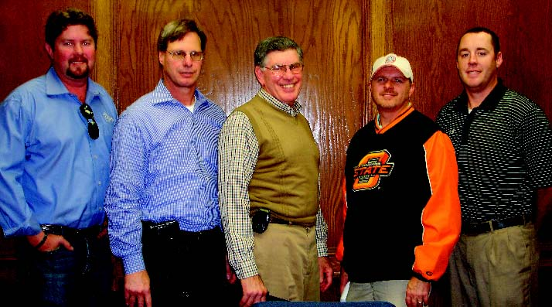

Brian Smith, Oakridge Builders in Tulsa; Jon Evans, Nashert Constructors in Oklahoma City; and Rick Tejada, Tulsa Dynaspan in Broken Arrow, congratulate construction management students Mark Williams of Jenks and Jared Shipman of Broken Arrow on receiving $1,000 scholarships from the Oklahoma Construction Advancement Foundation.
Courtesy Genesee Photo
Alumni Name Seniors of Significance
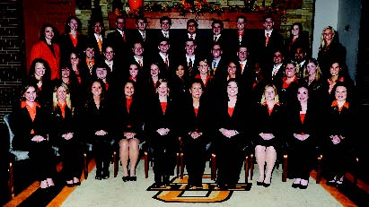and biochemistry and molecular biology; Aubrey Gooden, Edmond, finance; Adam Greer, Tulsa, nutritional sciences; Renee Hale, Hopewell Junction, N.Y., chemical engineering; Jayne Harris, Fort Gibson, health education and promotion; Hailey Harroun, Bellingham, Wash.,
animal science and agricultural communica
tions; Carrie Highfill, Enid, food science; Sarah Hodge, Murphy, Tex., marketing; Ideen Jahanshahi, Stillwater, mechanical engineering;
Michelle Jones, Medford, animal science and
agricultural communications; Leah Kuehn,
Sidney, Neb., animal science and agricultural
communications; Jessica Lay, Broken Arrow, biosystems engineering; Megan McCool, Cushing, agricultural communications; Clint Merritt, Ardmore, animal science; Bridget Miller, Wylie, Tex., health education and promotion; Jessica Moore, Fairfax, landscape architecture; Kalyn Neal, Oklahoma City, agribusiness;
R. Tyler Powell, Guthrie, agribusiness; Travis Schnaithman, Garber, agribusiness; Kayla Spalvieri, Chandler, elementary education; Beau Stevens, Nacogdoches, Tex., fire protection and safety technology; Sadie Stockdale, Springfield, Mo., political science; Taryn Tate, Shawnee, nutritional sciences; Jared Whittington, Cushing, sociology; Jonathon Wyckoff, Blackwell, accounting and finance; and Hayley Zimmer
man, Dallas, Tex., international business and Spanish.
OSU student data mining team members Syed Nawaz, Liz Garmendia and Vineet Jain placed second at M2009, the annual SAS Data Mining Conference. Teams were given a problem to solve and the top three teams won a cash prize for their university. Goutam Chakraborty is faculty adviser.
OSU’s Cross Country team won its second NCAA men’s cross country championship on Nov. 23 in Terre Haute, Ind. OSU has now won 49 NCAA team championships The team is coached by Dave Smith, who was named National Coach of the Year.
Tulsa junior Nicole Weidman is an intern this fall at the NASA Wallops Flight Facility in Wallops Island, Va., with the NASA
Undergraduate Student Research Program. Only 18 students nationwide were chosen to intern at NASA centers across the U.S. She expects to receive a double major in aerospace and mechanical engineering in May 2011 from OSU.
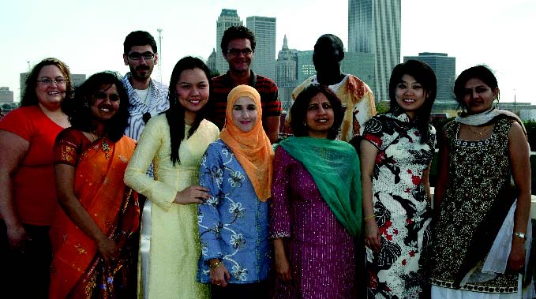
OSU-Tulsa’s International Student Organization hosted “International Night: Beyond the Orange” with songs, dances, original music, poetry and a fashion show by students from China, India, Kenya, Malaysia, Russia, Iran, Morocco, Colombia, Pakistan, Saudi Arabia, Brazil, Lebanon, Thailand, South Korea, Vietnam, Jamaica and the U.S.
Bridget Miller, Wylie, Tex., health education and promotion senior and a captain of the Cowgirl soccer team, was honored by
the Big 12 Conference as OSU’s Fall 2009 Chick-Fil-A Community of Champions recipient. Chick-Fil-A will reward OSU
$3,000 for her achievements.
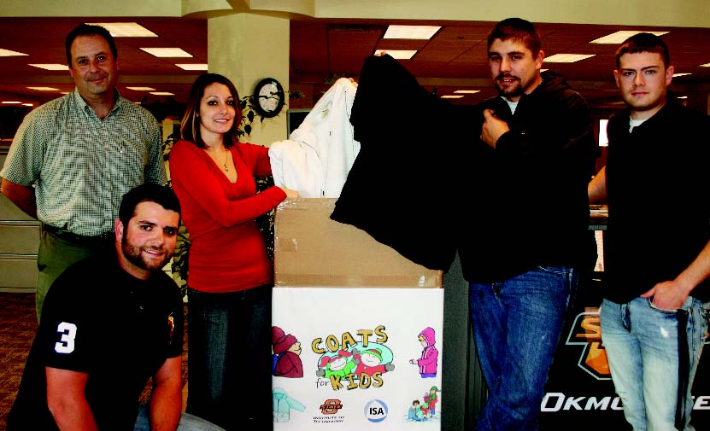
OSUIT’s International Systems and Automation Club collected coats through Nov. 30 to donate to area children. Holding some of the coats collected are Richard Thompson, Tahlequah; Art Visconti, engineering technologies instructor; Casey Polasek, Jenks; Nathan Woody, Morris; and Clayton Walker, Durant.
Human Environmental Sciences graduate students and the Hotel and Restaurant Graduate Student Association hosted a “Mitten Tree” community service project to collect hats, scarves, mittens and cash donations for children and families served by Stillwater Domestic Violence Services.
In October, OSU Army ROTC conducted its fall field training exercise. More than 80 cadets participated in rappelling, basic rifle marksmanship, land navigation, and high ropes,
leadership and team building training. The exercises prepare OSU cadets for the leadership development and assessment course at Fort Lewis, Wash., where cadets from throughout the nation participate. OSU Army ROTC consistently produces cadets that rank in the top 10 percent of the nation at the course.
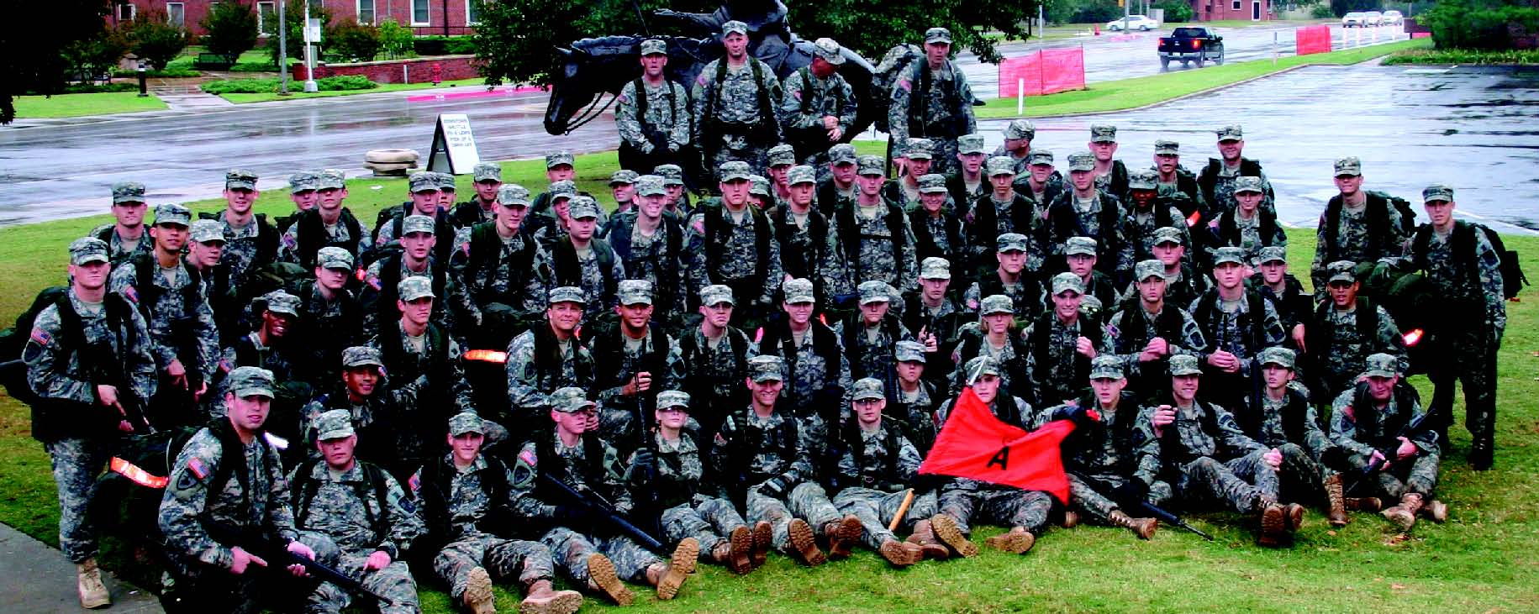
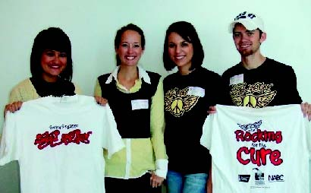
Spring Sing executives went to St. Francis Hospital in Tulsa on Oct. 30 to visit the pediatric oncology unit to pass out Spring Sing T-shirts to the children and families. The visit was arranged by Kendria Cost of the Seretean Wellness Center. Spring Sing has raised more than $30,000 for OSU’s Coaches vs. Cancer campaign during the past four years. Visiting the hospital were Danielle Gregoire, Plano, Tex., executive director; Liz Osborne, adviser; Allison Lyons, Edmond, assistant executive director; and Micah Fewin, Woodward, executive director.
Alpha Psi, a veterinary honor society, has been active in picking up trash, visiting a nursing home, volunteering at the Tiny Paws Kitten Rescue and hosting a “Wine
for Whiskers” to benefit Tiny Paws.
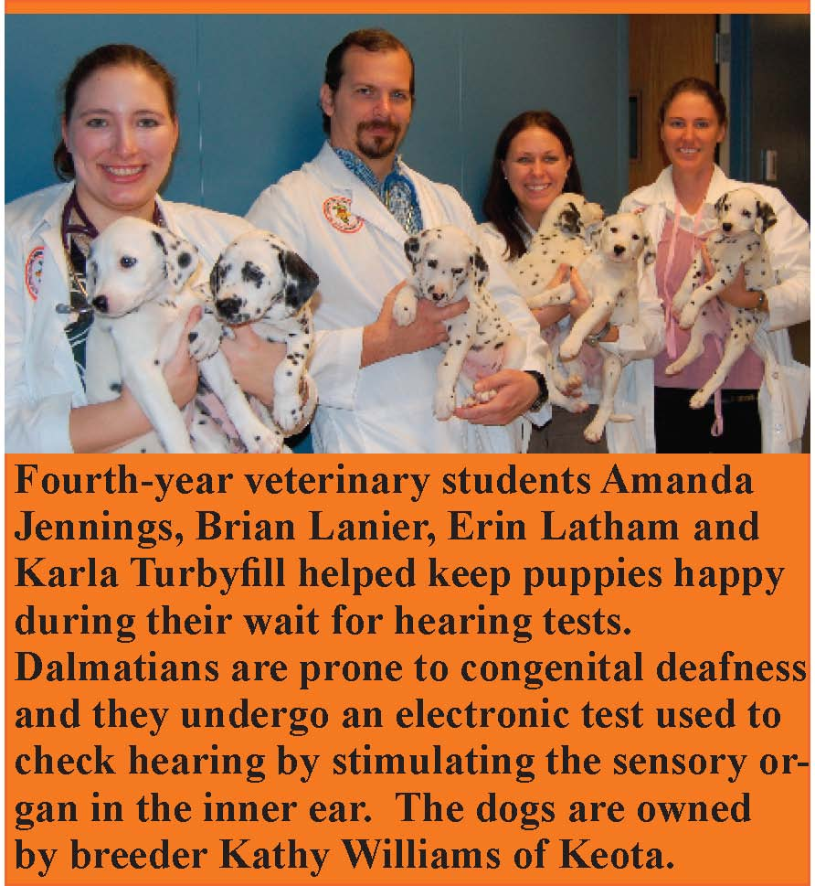
Drew Dawson, Stillwater chemical engineering senior, was elected chair of the Executive Student Council of the American Institute of Chemical Engineers.
The OSU-OKC campus collected more than 40 boxes of food for the “Students Against Hunger” Food Drive benefitting the Region-al Food Bank of Oklahoma. Almost every division and area contributed to the drive.
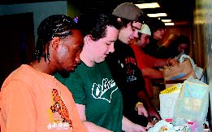
The OSU Native American Faculty and
Staff Association awarded freshman scholarships to Tiffany Treat, Beggs secondary math education, and Quinn Rogers, Wetumka agribusiness. Nicota Postman, Ponca City design, housing and merchandising sophomore, received a transfer scholarship.
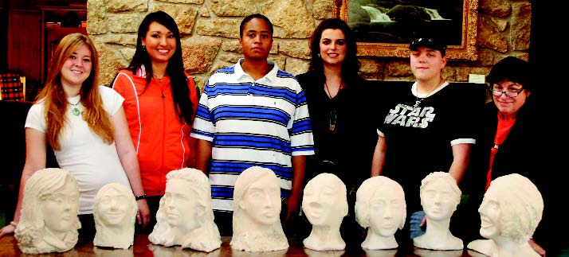
Art professor Sallie McCorkle’s Sculpture I class completed self-portrait busts, and their art is on display at the Willham House, the residence of OSU President Burns Hargis and his wife, Ann. With their busts are Krystal Richie, Lauren Loftis, Elizabeth Needham, Jessica Moore, Latrisha Godwin and McCorkle.
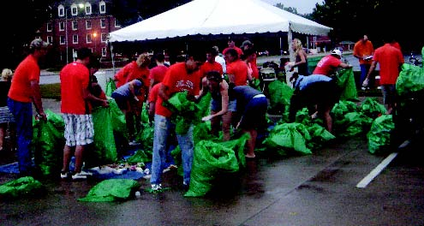
OSU’s Sustainability Committee collected and sorted aluminum cans before, during and after home football games. They collect
ed 65,238 aluminum cans for Habitat for Hu
manity, which received cash for recycling them, said Jesi Lay, committee chair.
Santhosh Duraisamy, Hyderabad, India, management and information systems graduate student, was awarded a scholarship to attend the 2009 South Central SAS Users Group
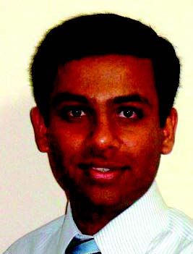
Educational Forum in San Antonio. He
was selected for his research and utilization of multiple SAS software packages.
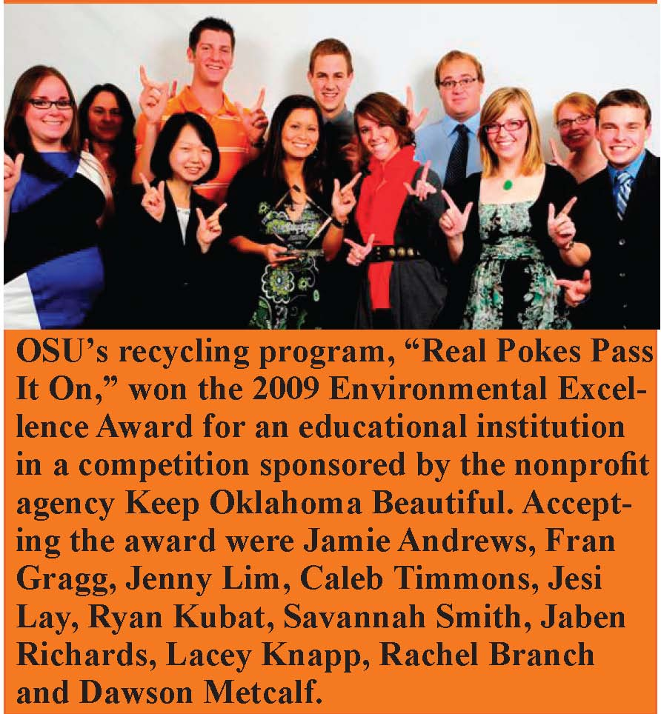
Cowboys with Compassion collected coats and items to keep people warm to be distributed to those in need during the Still
water Project Food Distribution on Dec. 9,
according to Steven Blair, Miami marketing senior, and Maranda Rea, Eufaula physiology senior.
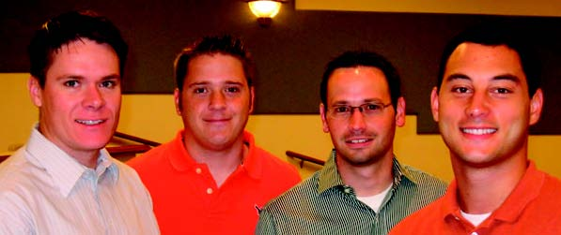
2009 Spears School MBA Executive Interaction Case Competition winners were Preston Pollard, Enid; Tommy Christian, Houston; Eric Sailers, Lawton; and Nick Kila, Mannford. Teams analyzed and solved a current real-world problem for VMWare, Inc., a virtualization technology leader, and presented recommendations for enhancement and growth for the company.
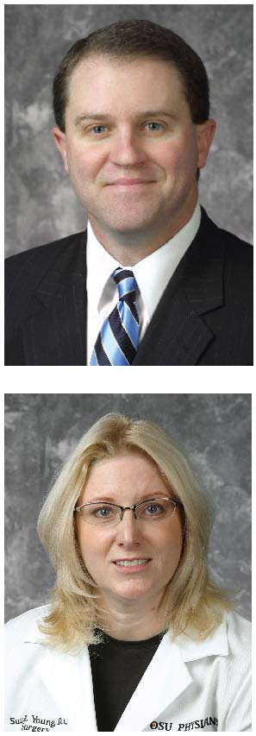Two assistant professors of surgery at OSU-CHS, Brian C. Diener, D.O., and Susan B. Young, D.O., have been desig
nated as Fellows of the
American College of Osteopathic Surgeons. The designation is conferred in recognition of voluntary activities and service to advance osteopathic medicine and surgery.
The OSU-OKC Development Office received the $7,500 first installment of a $15,000 pledge from American Fidelity Foundation to fund the OSU-OKC Early Care Education Childland Security Institute during summer 2010.
OSU President Burns Hargis was among
inductees into the Oklahoma Hall of Fame.
This year’s inductees joined the 628 people who have been inducted into the Oklahoma
Hall of Fame since 1928.
The 42nd Annual Frontiers of Power Conference to explore current trends in electrical transmission and distribution reliability assessment, related energy generation, smart grid, educational and public policy issues, was held at OSU in October. It was co-sponsored by the Engineering Energy Laboratory and the OSU School of Electrical and Computer Engineering.
OSU-Tulsa hosted approximately 700 information technology professionals for Tulsa TechFest on Nov. 6. The technology conference featured keynote speaker Joe
Fletcher from Microsoft.
Eleven new College of Arts and Sciences faculty members spent Nov. 7 on the road getting to know the state and its people a little better. The group traveled from Stillwater to Bartles-ville to Tulsa with a few stops on country back roads. The day kicked off in Bartlesville with tours led by OSU alumnus Joe Williams, ’67. Among those accompanying them were Peter
Sherwood, dean. Brad Bays, geography professor, and Walter Shaw, outreach director, coordinated the event.

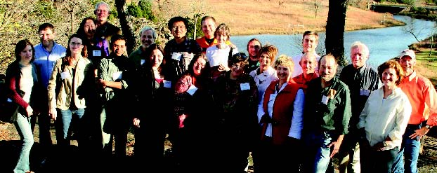
The University Continuing Education Association gave OSU an excellence award for the HAZWOPER First Receivers Training Program. The College of Engineering, Architecture and Technology Continuing Education contracted with the Oklahoma Department of Health to provide the training to hospital employees who may be exposed to hazardous materials while administering medical attention to patients.
Art history professor Marcella Sirhandi was invited to serve as a juror for graduate students at the National College of Arts in Lahore, Pakistan, where she helped create the master’s in arts program.
Barry Pollard, Waukomis, an Enid neurosurgeon, will chair the 2009-10 OSU
Foundation Board of Trustees. He founded
OSU Medical Cowboys, a group of health-care professionals, to fund scholarships for students in each graduating class.
A $10,000 grant from Cancer Sucks, Inc., to OSU-CHS has helped purchase
an Accuri C6 Flow Cytometer System.
Rashmi Kaul, immunology associate professor, said the cytometer will help with cancer and clinical research, especially in conducting studies to understand how Hepatitis C in the liver leads to development of cancer. Matching funds from the
Oklahoma National Science Foundation
EPSCoR Research Infrastructure Improvement Award and the NIH IDeA Network for Biomedical Research Excellence Award assisted the purchase.
Gary Trennepohl was honored for his 10-year service as OSU-Tulsa’s first president on Nov. 1 at the Oklahoma Jazz Hall
of Fame.
OSU-OKC’s annual Counselor Appreciation Luncheon had the largest turnout in the event’s history.

Veterans Day Events
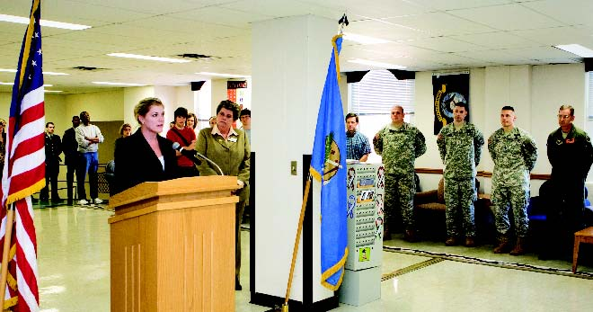
Veterans Day, Nov. 11, marked the opening and dedication of the Student Veteran’s Lounge at OSU. The
lounge is located on the 4th floor of the Student Union
in the northwest corner. Abby Speed, Student Veterans Organization president and an Air Force Staff Sergeant, worked with Lee Bird, vice president for Student Affairs, and Marlene Strathe, provost and senior vice president, to bring the idea of a Veteran’s Lounge to a reality.
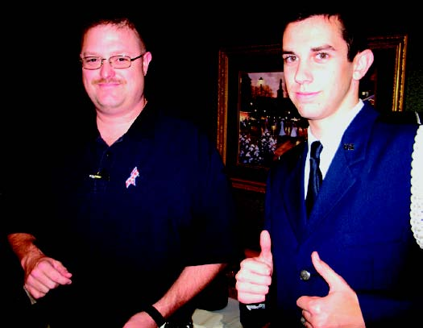
Nearly 40 OSU-OKC veterans, their families, staff, faculty and civilians attended the first Veterans Day Reception Nov. 11 on campus. Veterans represented the Korean, Vietnam, Afghanistan and Iraq wars and several branches of the military.
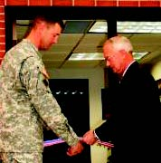
Lt. Col. Curtis Bohlman and OSUIT President Bob Klabenes cut the ribbon to the new Veterans Resource Center and National
Guard Recruiting Office, located
in the college’s Student Union. The resource center will be an inviting place for students who are veterans to study, relax and socialize.

The
Division of Agricultural Sciences and Natural Resources
will partner with the University of Arkansas to sponsor the 29th Annual Oklahoma and Arkansas Hor

ticulture Industries Show on Jan. 8-9.

Robert Spurrier, OSU Honors College director, was elected to a three-year term as secretary of the National Collegiate Honors Council, the largest national educational organization for honors education.
OSU-OKC hosted a High School to College Disability Services Transition Workshop Nov. 5 for metro area high school special education professionals and postsecondary education disability services providers, according to Emily Cheng, OSU-OKC academic adviser to students with disabilities.
Daniel Archer, OSUOKC academic adviser/ international adviser, was elected president of the Oklahoma Academic Advising Association in November. OACADA is a statewide professional organization for academic advisers.
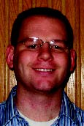

The Spears School of Business inducted three alumni Stan Clark of Stillwater, founder and president of Stan Clark Companies; Beverly Lancaster of Wichita, retired president and CEO of Learjet; and
Brad Williams of Houston, tax partner with Ernst & Young, into the Spears School of Business Hall of Fame. Recognized as Outstanding Young Alumni were Angela Courtin of Los Angeles, senior vice president of marketing, entertainment and content for MySpace; Bruce Yee of Houston, supervisor of IT projects business analysis and reporting for ExxonMo
bil Global Business Services; and Mita Young of Houston, asset manager for Horizon Wind Energy.
The U.S. Department of Energy awarded OSU’s Industrial Assessment Center a $105,000 grant to provide no-cost energy assessments to eligible small and medium-sized manufacturers. The funding also supports the IAC as a training ground for the next generation of energy-savvy engineers. Housed in the College of Engineering, Architecture and Technology, the IAC serves clients in Oklahoma, Kansas, Arkansas and North Texas.
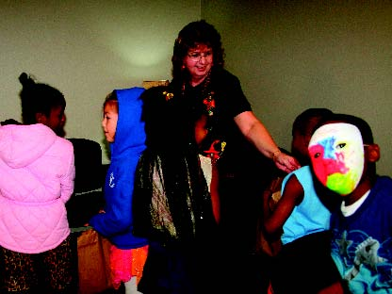
Students from Eugene Field Elementary School attended a Halloween trick-or-treat costume parade at OSU-CHS, where OSU staff members, including Linda Lawrence, clinical education program specialist, handed
out treats. More than 250 children attended
the event. Eugene Field is OSU-CHS’s adopt-a-school.
2009 Distinguished Ag Alumni are Claud Evans, Okemah, veterinarian; Ken Starks, Stillwater, executive regional vice president of BancFirst; Mark Hodges, Forgan, executive director of the Oklahoma Wheat Commission and director of Plains Grains Inc. and executive director, Oklahoma Genetics, Inc.
K.D. Berlin, Regents Professor of organic chemistry, and Bill Handy, journalism and broadcasting associate professor, were inducted into Golden Key International Honor Society as honorary members for their work and commitment. Golden Key also inducted about 300 new junior, senior and graduate student members who represent the top 15 percent of their classes.
Todd Holbrook, equine medicine associate professor and equine section chief, was elected a veterinary panel member for the selection of the U.S. Endurance Team for the 2010 World Equestrian Games.
Robert Burnap, microbiology and molecular genetics professor, was invited to serve as the program director for the Division of Molecular and Cellular Biosciences at the National Science
Foundation.
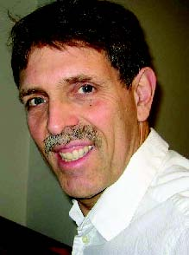
Ken Eastman, associate professor and head of management, received the 2009 Richard W. Poole Faculty Outreach Excellence Award and the 2009 OSU Outreach
Faculty Excellence Award in the Spears
School of Business, and the 2009 Great Plains Region Excellence in Teaching Award from the University Continuing Education Association.
The College of Engineering, Architecture and Technology inducted graduates Charles Kridler, Joe Mitchell Jr. and Sridhar Mitta into its Hall of Fame on
Oct. 23. Kridler is principal and director of
retail services for Gensler, a San Francisco architecture and design firm; Mitchell is
chair and CEO of four companies engaged in oil and gas, oil services, real estate and
cattle in Glen Rose, Tex.; and Mitta is
recognized for nurturing the information technology revolution in India.
Jennifer Borland, art assistant professor, was awarded a Mellon Postdoctoral Fellowship with the Penn Humanities Forum
at the University of Pennsylvania.
Jessica Roark, OSU Honors College assistant director, was elected vice president of the Great Plains Honors Council this fall and installed during a conference in Washington, D.C.
Four veterinarians received the 2009 Distinguished Alumni Award from the OSU College of Veterinary Medicine. Recipients were James Carpenter, ’74, Kansas State University; Anthony Confer, ’72, OSU; Robert Hudson, ’55, Auburn University; and Gary White, ’68, OU Health Sciences Center.
Johnson Controls Foundation donated $10,000 for a portion of the telemetry equipment for the cardiac catheterization unit for the Center for Veterinary Sciences. The Kirkpatrick Family Fund gave a $10,000 gift to provide three of the four needed datascope monitors for the newly
renovated Kirkpatrick Foundation Small
Animal Critical Care Unit.
OSU Student Groups Support Troops
OSU’s Student Veterans Organization sponsored “A Cowboy Christmas” to collect items to be sent to deployed troops in Afghanistan.
“We chose Afghanistan as the location to send the packages because it’s very difficult to get even the bare necessities there,” said Abby Speed, SVO president.
“Red Shirt, Orange Friday,” sponsored by the OSU Agricultural Communicators of Tomorrow, allowed Cowboys to show their support for the troops on Oct. 2, with proceeds from the sale of special red shirts helping to fill soldier care packages, according to Megan Mc-Cool, ACT president.
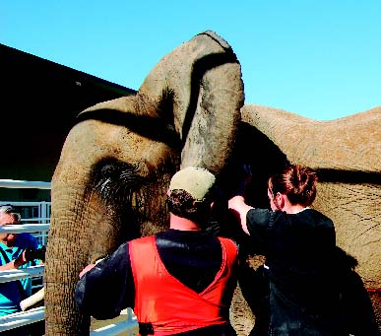
Students at OSU’s Center for Veterinary Health Sciences recently had a rare opportunity to get an up-close look at a performing elephant. Kamba, a 29 year-old female African elephant owned by Doug Terranova, left, was referred to the center’s OSU Boren Veterinary Medical Teaching Hospital after wandering away and being hit by an SUV on a highway near Enid. Luckily, the couple in the SUV escaped with no personal injuries and Kamba was treated and released back to her owner. OSU veterinary technician Jill Murray, right, helps prepare Kamba for X-rays of her left front leg.
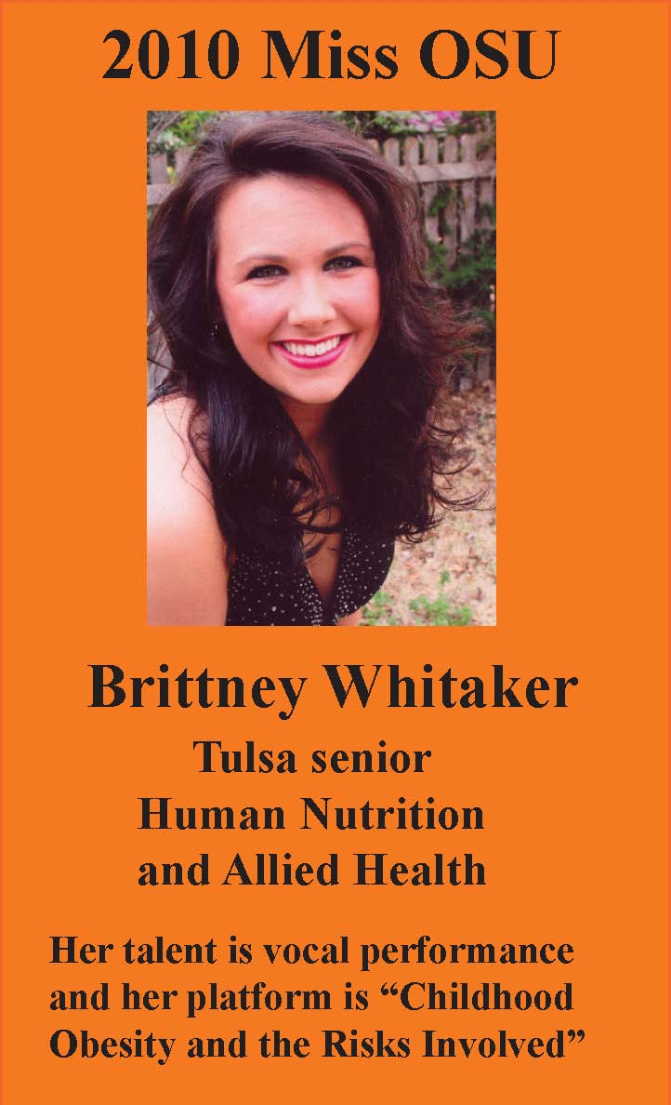
OSU Flight Team Qualifies for National Competition
The OSU Flight Team placed fourth in the National Intercollegiate Flying Association Region 6 competition in Norman and secured an invitation to the national competition at Indiana State University on May 17-22, 2010.
The team also took third in flying events.
Steven Roberts is the adviser and coach.
Members of the flight team for the competition and their wins were Adam Campbell, The Woodlands, Tex., aerospace administration and options senior, second place, top pilot, first place, power off landing, and first place, short field landing;
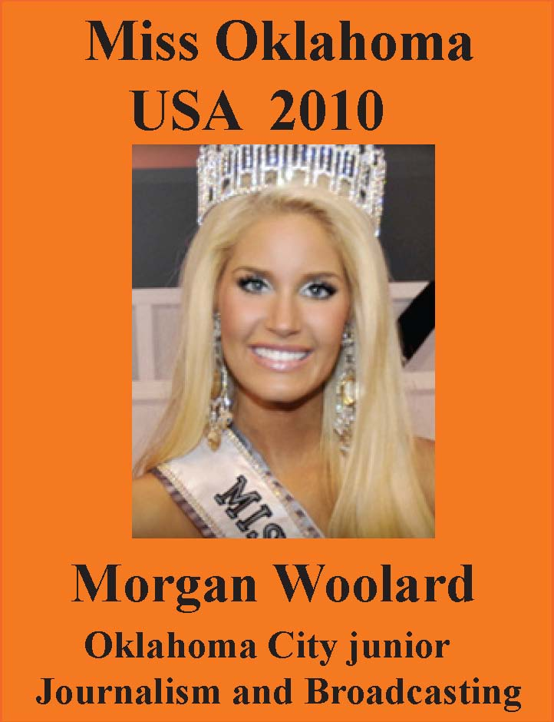
Robin Laws, Stillwater natural and applied sciences graduate student, fourth place, top female; David Hayes, Owasso aerospace administration and options senior,
fifth place, power off landing, fifth place, short field landing; Barrett Hammontree,
Richardson, Tex., aerospace administra
tion and options senior, first place, aircraft recognition test; Evan Gall, Christians-burg, Va., aviation sciences senior, fifth place, aircraft recognition test; and
Brandon Hays, Seneca, Mo., aerospace
administration and options junior, first
place, simulated comprehensive aircraft navigation.
OSU-OKC students Deshelda Hall and Britney Guerriero are featured on the Oklahoma House of Representatives Internship Web site. They recently interned with the House of Representatives and shared their experience with potential interns. Hall obtained her associate in public service
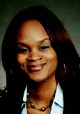
Hall
degree from OSU-OKC this spring, and Guerriero is currently a student.
OSU-Stillwater’s Harvest II food drive winner was the English Department with 2,176 points. IT Software Services came in second with 1,890 points.
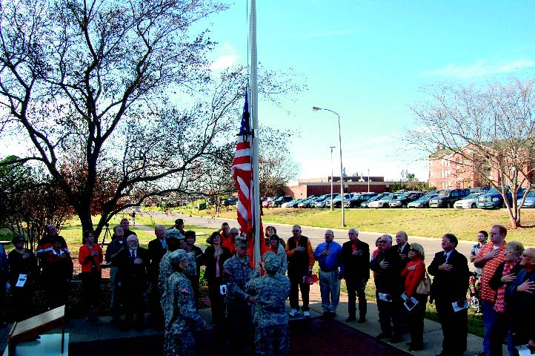
More than 50 people attended the dedication
ceremony for the OSU Center for Veterinary Health Sciences’ Military Veterinarian Honor Court. Major General James Sholar said that since the veterinary college began in 1948, OSU has graduated 400 service members of the armed forces with 30 Cowboy veterinarians currently serving. The honor court recognizes the many OSU veterinarians who serve in the military at one point in their veterinary medicine career. Inscribed bricks to honor OSU veterinarians who have served or are serving in the military may be purchased.
OSU-OKC staff members Joaquin Ruiz, Hispanic Student Services campus representative, and Robert Hollen, business division academic adviser, received cash awards for their Creative Staff Innovation ideas at the Fall 2009 Oklahoma Association of Community Colleges Support Staff conference. Ruiz won second place and Hollen took third place.
Bryan Edwards, management assistant professor, and Kevin Gue, Auburn University, received a $54,000 grant from the Material Handling Industry of America and the College-Industry Council on Material Handling Education for a broad-based study of the material handling industry.
Ray Huhnke shows how a biobased economy with “green” renew-able energy crops will enhance current fossil fuel technologies.
A record attendance for a Pickens Town Hall was set on Oct. 29 when T. Boone Pickens came to Gallager-Iba Arena to discuss his national movement toward a new energy future.
Jeyasingh
Courtesy Genesee Photo
Alumni Name Seniors of Significance
In October, OSU Army ROTC conducted its fall field training exercise. More than 80 cadets participated in rappelling, basic rifle marksmanship, land navigation, and high ropes,
leadership and team building training. The exercises prepare OSU cadets for the leadership development and assessment course at Fort Lewis, Wash., where cadets from throughout the nation participate. OSU Army ROTC consistently produces cadets that rank in the top 10 percent of the nation at the course.
The OSU-OKC campus collected more than 40 boxes of food for the “Students Against Hunger” Food Drive benefitting the Region-al Food Bank of Oklahoma. Almost every division and area contributed to the drive.
Eleven new College of Arts and Sciences faculty members spent Nov. 7 on the road getting to know the state and its people a little better. The group traveled from Stillwater to Bartles-ville to Tulsa with a few stops on country back roads. The day kicked off in Bartlesville with tours led by OSU alumnus Joe Williams, ’67. Among those accompanying them were Peter
Sherwood, dean. Brad Bays, geography professor, and Walter Shaw, outreach director, coordinated the event.
