
September 11, 2009

OSU System Posts Enrollment Gain Over Fall 2008
Total enrollment for the Oklahoma State University System is up 4.5 percent this fall with 33,464 students, the school announced Friday during the regular meeting of the OSU/A&M Board of Regents.
Every campus posted an increase over fall 2008. Enrollment for the Stillwater and OSU-Tulsa campus is 22,845, which is up from 22,768 last fall. Graduate students posted the highest gains with 4,667 students this fall, compared with 4,463 last year, an increase of 204 students.
OSU Institute of Technology posted an enrollment of 3,015, a
2.7 percent increase; OSU-Oklahoma City has an enrollment of 7,179, a 21 percent increase; and the OSU Center for Health Sciences has an enrollment of 425, an increase of nine students from the previous fall. System-wide enrollment of 33,464 was up 1,432 students from last year’s total of 32,032.
“In these uncertain economic times we are extremely pleased to see these increases,” said OSU President Burns Hargis. “We have worked harder than ever to attract students to our campuses. Higher education offers a passport to a better future and Oklahoma State University provides students academic excellence in virtually every field of study.”
OSU’s Stillwater campus welcomed 3,148 new freshmen for the fall 2008 semester, and the quality of these students has set new records, Hargis said.
A record-setting 540 freshmen, more than 17 percent of the freshman class, had perfect 4.0 grade point averages, and more than
27 percent of the entering OSU freshman class ranked in the top 10 percent of their high school graduating class.
Prior to seeing the Cowboys win their season opener against Georgia, a huge crowd of fans were on hand for the
dedication and ribbon cutting that officially opened Boone
Pickens Stadium on Sept. 5. And for the second time in a month, OSU is on the cover of Sports Illustrated.
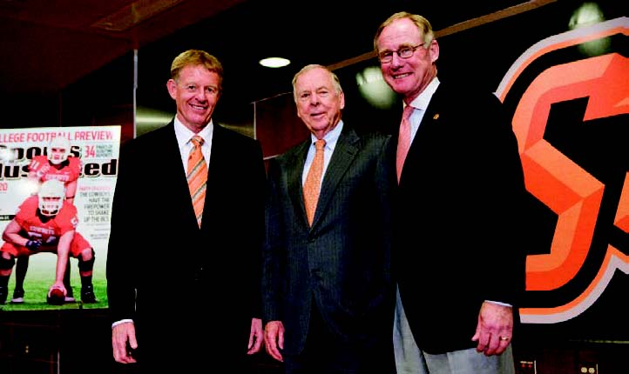
“This number of new freshmen with perfect GPAs is the highest of any university in the state of Oklahoma, and we are thrilled that this group of exceptional scholars selected Oklahoma State University for their higher education,” Hargis said.
The average ACT score of this newest incoming class, 24.9, also is an all-time high for OSU.
Of the freshman class, 300 students were valedictorians of their high school classes, bringing the total number of Oklahoma high school valedictorians who are studying at OSU to 1,580.
“OSU has long attracted the best and the brightest of Oklahoma’s students, which is evident by the number of high school valedictorians who select this university,” Hargis said. “OSU recognizes the importance of attracting and keeping in Oklahoma the brightest and most creative students in our state. These students are the future of our state and of our economy.”
The Stillwater campus is also the home to 11 new National Merit Finalists or National Merit Scholars, 24 National Hispanic Scholars, 119 Academic Scholars, and three National Achievement Finalists or Scholars. OSU’s international student enrollment is the largest in four years, according to Tim Huff, International Students and Scholars manager. This fall, 1,786 international students are enrolled representing 114 countries.
On Aug. 17, OSU graduate and benefactor
Boone Pickens, center, saw for the first time OSU’s new football facilities, a mammoth $180 million west end zone addition to the
stadium that bears his name. He was given a
personal tour through the first-class facilities of the new west end zone and a first look at what can aptly be called a monumental milestone for OSU athletics. Accompanying him were OSU Athletic Director Mike Holder, left, and OSU President Burns Hargis, right.

More than 1,400 new students gathered on the library lawn with President Burns Hargis and his wife, Ann, for an ALPHA group photo. ALPHA registration closed early this year due to the large student response. The three-day experience helps freshmen make friends, learn their way around campus, and kick off the new school year.
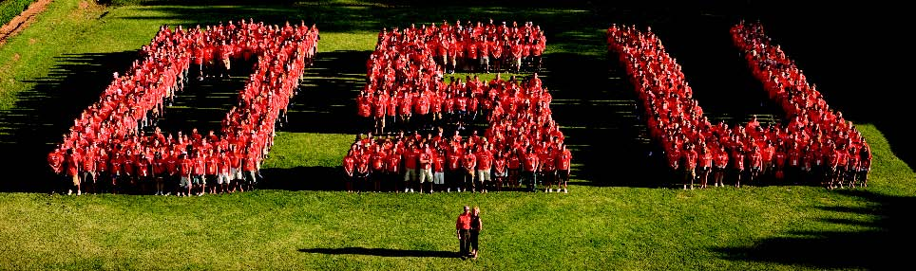
DASNR Receives Grant to Study Redcedar
OSU’s Division of Agricultural Sciences and Natural Resources will receive a $226,890 grant from the U.S. Geological Survey through the Oklahoma Water Resources Research Institute to study eastern redcedar encroachment and the water cycle in the tallgrass prairie, two key elements of ecosystem health for Oklahoma.
“Oklahoma is one of the key U.S. locales where woodlands meet grasslands,”
said Chris Zou, natural resource ecology and management assistant professor and principal investigator of the study.
“Of Oklahoma’s 17 million acres of rangeland, including prairie, eight million acres are currently overgrown with eastern redcedar,” said Dave Engle, OSU’s Thomas E. Berry Endowed Chair in Integrated Water Research and Extension. “That number increases 762 acres a day.”
Zarrow Foundation Helps Shelter Medicine
The Anne and Henry Zarrow Foundation in Tulsa has made a $150,000 commitment to the OSU Foundation to benefit the Cooperative Shelter Medicine Program between the city of Tulsa and the OSU Center for Veterinary Health Sciences.
It has provided the first $25,000 in funding and will make further payments annually. This gift covers the costs necessary for the program to expand to Tulsa this fall after succeeding in Edmond, Norman,
Perkins and Stillwater.
Through the shelter medicine program, CVHS students complete three-week rotations at the shelters where they perform spaying, neutering and wellness care. The city of Tulsa pays for the veterinarian and OSU provides support staff, and the public will receive spay and neuter services at a reduced rate. This program also promotes the adoption, rather than euthanization, of sheltered animals.
Exchange Agreement Signed with University of Philippines
OSU and the University of the Philippines Los Baños have signed a reciprocal exchange agreement for undergraduate students who wish to study in the Philippines.
The agreement, signed by OSU Provost Marlene Strathe and UPLB Chancellor
Luis Rey I. Velasco, will enable OSU students to enroll and study at UPLB while paying OSU tuition and fees.
Founded by an American scientist in 1909, UPLB offers more than 1,000 courses in English.
Fallon, Aldean Headline 2009 Orange Peel
Jimmy Fallon, comedian and late night
talk show host, and country music rocker
Jason Aldean will headine OSU’s Orange
Peel festival in Stillwater on Oct. 3 in Gal
lagher-Iba Arena.
Orange Peel is a concert and pep rally
organized by selected student leaders
each year to provide the OSU family with
national and local headline entertainment.
Since its inception, more than 200,000
people have attended Orange Peel. It is
now the largest student-produced and stu
dent-run event in the country, with almost
200 students contributing to the annual program.
This year marks the second Orange Peel production to be held indoors, so weather will not be a factor for the show, according to Kristen Kenaga, executive director and Enid early childhood education senior.
Tickets are available online at shopokstate.com, by telephone at (877) OSUPEEL, and at the Student Union Bookstore. Doors open at 6 p.m. with the show beginning at 7 p.m. All tickets are $42 each and are reserved seating.
OSU-OKC Adds Class Sections for Fall Influx
OSU-Oklahoma City added 110 class sections to its fall 2009 course lineup in order to accommodate the influx of students enrolling at the university.
According to Larry Edwards, vice president of academic affairs, the economy was a leading factor in the university’s exponential growth.
“Enrollment tends to be counter-cyclical with the economy,” said Edwards. “When the economy is bad, people go back to school.”
The marketing of a scholarship called “The Club – Buy 2 Get 1 Free” also encouraged more than 600 students to commit to attending OSU-OKC for two semesters in order to get their third semester free. Degree completion was the focus of that program, he said
Arts and Sciences had a 24 percent growth, Science and Engineering had a 43 percent growth, Human Services had a 24 percent growth, and the rest of the programs also had exponential increases in enrollment.
The first tracheal stent placement in a dog at OSU’s Veterinary Medical Teaching Hos-pital can been seen in the X-ray.
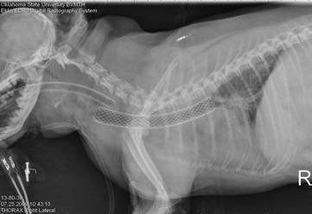
First Tracheal Stent At OSU Placed in Dog
OSU’s Center for Veterinary Health Sciences broke new ground on July 25 when Justin Thomason, OSU small animal internal medicine, assisted by Mark Davis of Dallas, performed the first tracheal stent placement in a dog at OSU’s Veterinary Medical Teaching Hospital.
“The stent placement went very well,” said Thomason. “The patient presented with a severe tracheal collapse and had to be placed on mechanical ventilation prior to the procedure. The last chance for survival was this new procedure.”
Instead of a surgical incision, as was
done in the past, a fluoroscopy unit was
used to place the stent.

Leigh B. Goodson, OSU-CHS vice president of Sponsored Programs, Research and Institutional Advancement; David Wallace, assistant dean for research; and Robert Allen, professor and chair of forensic sciences, look over construction progress for the shared forensic sciences and biomedical research facility for OSU Center for Health Sciences and the city of Tulsa. Construction is on schedule for the 160,000-square-foot building. The first two floors are for police department use and the remaining three for OSU-CHS. Completion for the OSU floors is projected for early November 2010.
OSU Among Top 100 “Best Buys” at Forbes.com
OSU is the only public school in
Oklahoma among the top 100 “Best
Buys for College” in the latest Forbes.
com listing.
The list compares school quality to
costs and is promoted as an indepen
dent alternative to the annual U.S. News
and World Report list, since it does
not rely on the colleges themselves for
ratings.
OSU placed 85 in the top 100 best
buys. The only other Oklahoma school
to make the top 100 was Oklahoma
Baptist University.
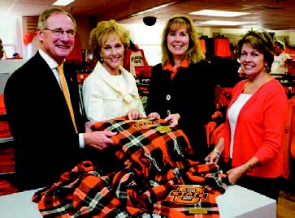
OSU President Burns Hargis, Ann Hargis, design, housing and merchandising professor Paulette Hebert, and former OSU licensing director Judy Barnard look over blankets woven in the official OSU tartan that are now available in selected stores. The plaid was designed by Oklahoma City interior design senior Stephanie Michalko.
New Scholarship Program Set For OSU-Tulsa and City
Mayor Kathy Taylor and OSU-Tulsa announced a new scholarship program for city of Tulsa employees to attend OSU-Tulsa. City employees will receive a scholarship equal to half of their tuition costs for up to six credit hours a semester at OSU-Tulsa.
OSU-Tulsa has budgeted $50,000 for the program, which will be allocated on a first-come, first-served basis. The scholarships are funded by the University Center Trust at no cost to the city of Tulsa.
To be eligible, students must be full-time employees of the city of Tulsa at the start of the enrollment semester and admitted to an OSU degree program.
Returning OSU-Tulsa students watched the planting of more than 300 campus trees.
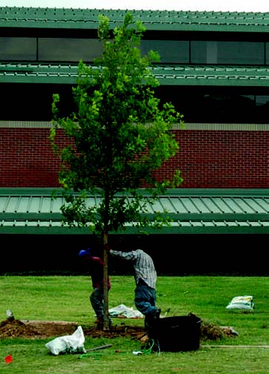
New Trees Return BeautyTo OSU-Tulsa Campus
More than 300 new trees were recently planted on the OSU-Tulsa campus to restore the beauty that was lost after more than 100 trees were heavily damaged following the December 2007 ice storm.
Tree species include Allee Lacebark Elm, Shumard Oak, Overcup Oak, Loblolly Pine, Nellie Stevens Holly, Black Gum and Red Sunset Maple. The trees are being planted in groupings to simulate those found in nature.
The landscape plan, created by Alaback Design, adds more evergreen trees for year-round visual impact and a variety of trees to provide colorful landscapes during the spring and fall. The project is being funded through the UCT Authority.
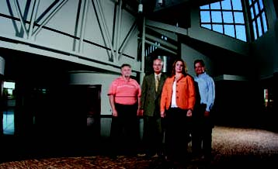
Bob Seebeck, Physical Plant Services director; President Bob Klabenes; Jana Martin, Allied Health Sciences Division chair; and architect John Sanford look over the new 22,000-square-foot Allied Health Sciences Center at the OSU Institute of Technology. The facility will be dedicated in October and will allow student enrollment to double in allied health programs.
Deng Awarded NIH Grant To Continue Research
Junpeng Deng, structural biochemist in biochemistry and molecular biology, along with his first-year Ph.D. student Brian Krumm, solved a three-dimensional crystal structure of a poxvirus protein in the act of disarming a human immune molecule, interleukin-18 (IL-18).
This scientific breakthrough was the first step toward a pharmaceutical medication for poxvirus-caused diseases, aid in national and international security efforts and a treatment for autoimmune diseases.
Deng was recently awarded a four-year $1.34 million grant from the National Institutes of Heath to continue this research.
Solving the three-dimensional structure last December allowed the understanding of where the poxvirus attaches to the IL-18, but Deng is now looking at how the IL-18 is functioning.
IL-18 must bind with its two receptor proteins on the cell membrane to activate the human immune response. Deng’s proposal to the NIH was to study the mechanism of how the signal to activate the immune response is occurring and is regulated. With this information, Deng, Krumm and their collaborators from the Texas Health Science Center in San Antonio will be able to develop a protein drug to bind those receptors to regulate the immune system activities.
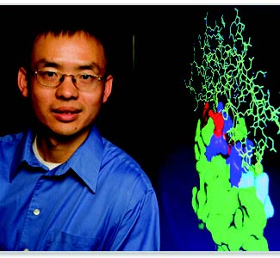
Dean Michael Lorenz, center, and other officials with the OSU Center for Veterinary Health Sciences, welcomed the 82 freshmen in the Class of 2013 during the traditional White Coat
Ceremony.
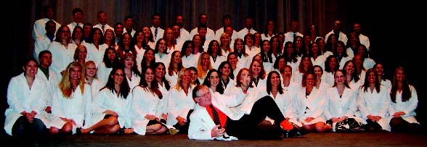
Abron Medcalf, Broken Arrow marketing junior, and Jenna Browne, Durant health and human performance junior, were
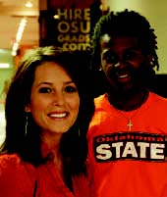named the number one Oklahoma interns for Enterprise Rent-A-Car this summer. Medcalf, a part-time employee of OSU Career Services, interned at Enterprises’ Tulsa location, and won in June. Browne, an OSU Foundation employee, worked at the Stillwater and Edmond locations and was named the top intern in July.
Nearly 1,500 youth from across the nation participated in the OSU Big Three Field Days, summer field days that cover beef,
sheep and swine, at the OSU Animal Science Arena. Approximately $3,100 in scholarships and more than 100 awards were given out this year. Teenagers in FFA and 4-H from Oklahoma, Kansas, Arkansas, Missouri, Texas and California participated.
Young women going through Panhellenic recruitment again selected the Rise School in Stillwater as their philanthropy project. In one day, 1,010 bags of school supplies were collected and delivered to the school, each bag weighing between two and three pounds, along with a donation of $249. Delivering the supplies were Erika
Curry, Panhellenic president;
Stephanie Hill
man, Panhellenic external vice president; and Amy Cobbs, Panhellenic continuous open recruitment coordinator.
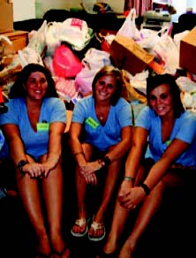
OSU Center for Veterinary Health Sciences’ graduate students Kelly Allen and Stephanie Heise received national awards for research excellence in veterinary parasitology from the American Association of Veterinary Parasitology. Allen received the AAVP-Intervet/Scherring Plough Outstanding Graduate Student Award for her research on a debilitating parasite of dogs, and Heise received the AAVP-CAPC Graduate Student Award in Zoonotic Diseases for her research on novel pathogens associated with the Lone Star tick.
Assa Kante, agricultural education, com-munications and leadership doctoral student, received a research scholarship to support her dissertation research in her home country of Mali. Her research will assess the effectiveness of a professional development program targeting mid-career agricultural extension educators, and the results will be used to make improvements in that program to boost the nation’s food security.
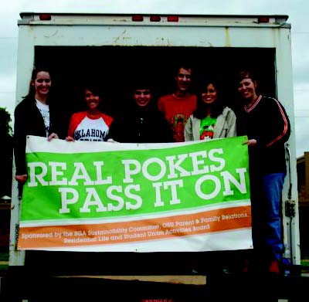
Real Pokes Pass It On, the Creativity Challenge program created through a partnership between the SGA Sustainability Committee, Residential Life, Parent and Family Relations and the Student Union Activities Board, raised more than $1,750 for Stillwater Domestic Violence Services and helped reduce waste and reuse items by selling useful items collected from students at the end
of the spring semester.
Of students who received free training in the OSU-Oklahoma City Certified Nurse Aide program, 641, or 77 percent, were
certified for fiscal year 2009. This number
does not include paying students, but it represents those who participated in the grant and signed a contract with the Oklahoma Healthcare Authority to work 12 months in a long-term care facility.
Approximately 100 fifth graders from
KIPP Tulsa College Preparatory kicked off their school year at OSU-Tulsa by attending classes and touring the campus.
School administrators planned the first day
of classes at OSU-Tulsa to emphasize that KIPP students are starting their education
where they will finish – at college.

Students in OSUIT’s CAT� Dealer Prep Program, all from Kansas, show off the recently donated Caterpillar 120 M Motor Grader, from the Wichita-based Foley Equipment Company, that will serve as a student-training module. Foley is one of four regional CAT� dealers that support the program by donating equipment and providing students with internships and eventual job
opportunities.
OSU’s Students in Free Enterprise club placed third in the national “Let’s Can Hunger Challenge,” a competition to develop projects geared toward raising awareness about hunger in the U.S. and providing hunger relief for local communities. For its project, OSU’s SIFE chapter worked outside various eating locations on campus for a month, selling non-perishable food, handing out questionnaires, and revealing facts about hunger in Oklahoma, according to Jeremiah Cole, OSU SIFE president and Oklahoma City marketing freshman. They also put bins for non-perishable food donations inside local Wal-Marts. SIFE worked with OSU’s chapter of Phi Beta Sigma, the Student Business Council, the Oklahoma Regional Food Bank and Wal-Mart to promote the cause and raise awareness.
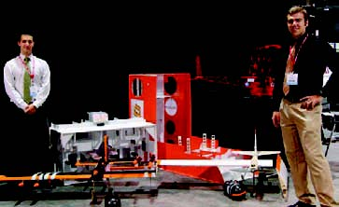
More than 1,000 high-profile visitors saw the
winning aircraft designs of OSU students
Alan Larson, Oklahoma City, and Eric Johnson, Caldwell, Idaho, at the U.S. Air, Trade and Technology Expo in Dayton, Ohio. Since OSU’s teams won both first and second place with the remote-controlled planes at the national AIAA Design/Build/ Fly competition in April, the aircraft were given a prime location for display at the Dayton International Airport’s Exposition Center. This was the first time the winning
designers were invited to participate in the
exposition to highlight the work of under
graduate students across the nation.
The Financial Management Association earned the FMA Superior Chapter Award for 2008-09. The award is presented to
fewer than five percent of FMA chapters
around the world and OSU has received the award 18 out of the past 19 years.
OSU Center for Veterinary Health Sciences graduate Sarah Gordon received the first Veterinary Student Advocacy Award from the Humane Society Veterinary Medical Association for her efforts to help promote the elimination of terminal animal surgical procedures in the veterinary curriculum. The association established the award to honor veterinary students who promoted humane and respectful treatment of all animals. Gordon, a Bartlesville native, graduated in May with a doctorate in veterinary medicine.
OSU Center for Veterinary Health Sciences students Amy Edwards, Class of 2011, and Brooke Washington, Class of 2012, were two of four veterinary students in the NIH’s Summer Internship Program last summer at the National Institutes of Health headquarters in Bethesda, Md. Dane Wilber, Cherokee plant and soil sciences senior, took second-place honors at the 2009 Southern Weed Society Collegiate Weed Undergraduate Contest Aug. 5 in Tifton, Ga. The competition required participants to apply their coursework to a real-world situation to solve problems.
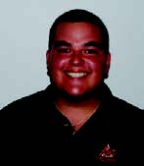
Janine Veronneau of Edmond, Class of 2011, represented OSU at the annual Smith-Kilborne program at Cornell University College of Veterinary Medicine and the Plum Island Animal Diseases Center in Long Island, N.Y., a program to acquaint veterinary students with foreign animal diseases that can threaten domestic animals.
Maria Vera, Tulsa chemical engineering junior, was selected to receive the BP Hispanic Engineer National Achievement Awards Conference Scholarship. She will receive an educational grant plus travel and hotel accommodations to the national conference in Long Beach, Calif., where she will be honored at a leadership dinner.
Due to popular demand and a high-yield growing year, the OSU-OKC Thursday Farmers’ Market will remain open in September, according to Cheryl Camp, OSU-OKC Farmers’ Market coordinator.
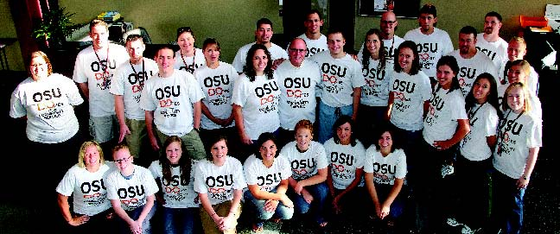
New OSU College of Osteopathic Medicine students got a taste of community life and volunteerism as part of their recent orientation week with projects at the Eastern Oklahoma Community Food Bank and at Eugene Field Elementary School, the medical school’s partner in education. The idea is to emphasize that they are part of the community from their first day at the OSU Center for Health Sciences, according to Stanley Grogg, interim CHS president, standing center (ninth person from the left). Students continue to volunteer during the year through local and area health fairs and service projects.
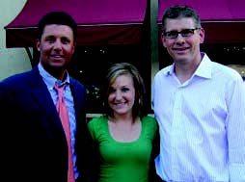
OSU coach
Mike Gundy,
Lauren
Blackwell and John
Anderson, “SportsCenter” anchor
Lauren Blackwell, Chicago broadcast journalism and sports media senior, was a summer intern at ESPN in Bristol, Conn., where she edited and produced highlights for segments of “SportsCenter” and “Baseball Tonight.” She received the ESPN internship through the Association for Women in Sports Media, and was one of six students in the nation awarded the
inaugural Betty Jean Moffitt Scholarship,
created by tennis legend Billie Jean King in memory of her mother.
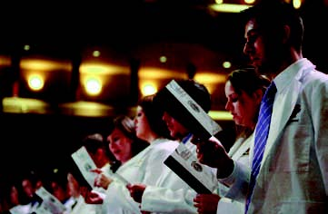
OSU College of Osteopathic Medicine student doctors recited the Osteopathic Medicine Oath of Commitment symbolizing their entrance into the osteopathic medical profes
sion at the white coat ceremony marking the
final step in their medical school orientation. The ceremony capped student orientation
week and marked the student’s transition
into a career of health care delivery.
The Fire Apparatus Manufacturers’Association awarded its 2009 Phillip L. Turner Fire Protection Scholarship to Benjamin
Eschner, McHenry, Ill., fire protection
and safety technology junior. He will receive $3,000 to recognize academic
achievement and fire service commitment.
OSU Mortar Board was one of 32 chapters in the nation to receive the Golden Torch Award at the national conference in July. The chapter also received two Project Excellence Awards for its nursing home outreach and “Reading is Leading” literacy efforts.
come a police officer
Micah Mirick won
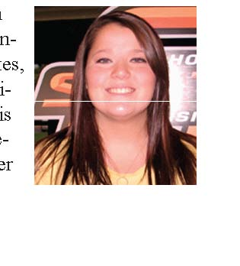

Antartica Project to Study Sea Level Change
s

Alex Simms, geology assistant professor, and Regina DeWitt, physics assistant researcher, received a $199,978 grant from the National Science Foundation to continue a research project on sea level changes in Antarctica.
Next spring, Simms and two graduate students will travel to the continent for six weeks to collect samples of beach depos
its. Using a technique known as optically stimulated luminescence, they will date the beach deposits to determine how the sea level has changed over the last several thousand years.
Determining the past thickness of the Antarctic ice sheet is critical to understand how ice sheets respond to sea level and climate change, Simms said.


Vashaee Working on Process for Clean Energy
Daryoosh Vashaee, OSU-Tulsa electrical and computer engineering assistant professor, is developing nanotechnology that can convert waste heat to energy.
His process to produce a clean, alternative energy source could significantly reduce the use of fossil fuels and help move the
U.S. toward energy inde
pendence. His research was
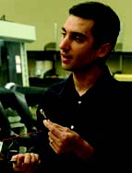
The International Council on Hotel, Restaurant and Institutional Education recently honored several College of Human Environmental Sciences Hotel and Restaurant Administration Department alumni, graduate students and faculty members at its annual conference in San Francisco. HRAD alumnus Gabriel Gazzoli, associate professor Murat Hancer and doctoral student Yumi Park received the conference Best Paper Award; assistant professor Hugo Tang earned the W. Bradford Wiley Memorial Best Paper of the Year Award; and alumnus Cihan Cobanoglu received the John Wiley and Sons Award for In-
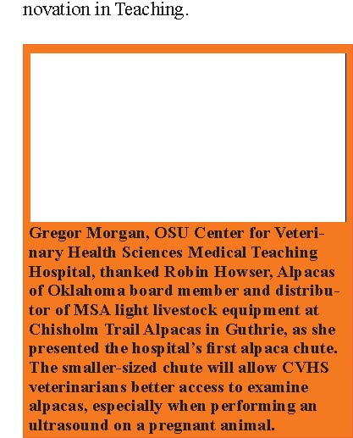
awarded a five-year, $700,000 grant from the Air Force Office of Scientific Research
and a three-year $200,000 grant from the National Science Foundation to perform research associated with thermoelectrics.
Vashaee and his engineering graduate students will use the AFOSR grant to develop thermoelectric materials that will harvest wasted energy from military aircraft at his lab in OSU-Tulsa’s Helmerich Advanced Technology Research Center.
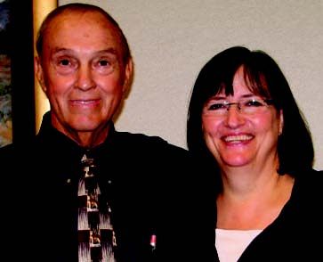
OSU-OKC President Jerry Carroll presented Interpreter Training Department head Joni Bice the OSU-OKC Pride Award on Aug. 17, an award for a faculty or staff member who exceeds expectations in their work and shows a true, on-going commitment to OSU-OKC.
OSU’s Non-Traditional Student As
sociation received a two-star certificate
from the Association for Non-Traditional Students in Higher Education in recognition of superior service and support of non-traditional students, according to Marie Basler, OSU coordinator of the Non-Traditional Student Organization. This is the highest ranking achieved of
the 47 uniquely identified institutions that
participated. The survey program was designed to gauge the services provided to non-traditional students at various institutions and provide feedback in the form of ranking.
Instructor Matthew Davis and OSUIT Air Conditioning and Refrigeration Program Chair Roger Shepherd check the input voltage to the variable frequency drive to the water pump on a geothermal heat and air unit. The unit in the Rural Health Center on the OSUIT campus is expected to cut utility costs by 30 percent. The ACR program is partnering with Tulsa Technology Center in October on a Green Jobs/Green Mechanical Seminar to teach energy efficient practices
within the industry.
The OSU-OKC Associate in Applied Science Early Care Education degree earned accreditation from the NAEYC Commission on Early Childhood Associ
ate Degree Accreditation, one of the first
61 institutions in the nation to earn this designation.
Michael Davis, Oxley Chair in Equine Sports Medicine and director of the Comparative Exercise Physiological Laboratory, received a $1 million Department of Defense award for a three-year study of endurance exercise metabolism using racing sled dogs as a model.
OSUIT recognized employees for their years of service and presented the Outstanding Staff Award to Regina Foster, Cooperative Alliance coordinator, and the
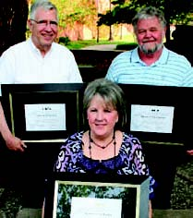
Himes, Nelson, Seebeck
Outstanding Faculty Award to nursing instructor Leah Torbett. Special honorees included Bob Seebeck, 40 years; David Himes, 35 years; and Noreen Nelson, 30 years.
Pamela Lloyd, physiological sciences assistant professor, received a grant from the National Heart, Lung, and Blood Institute of the National Institutes of Health to investigate mechanisms controlling the expression of placenta growth factor, a protein that contributes to blood vessel
growth. The five-year project has a budget
of $250,000 per year.

President Burns Hargis
and his wife,
Ann,
visited four freshman classes in the Classroom Building on Aug. 17 to wel

come students on the first day of class.
OSU Center for Health Sciences professor Richard Wansley was awarded a
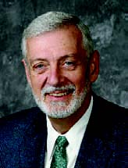$100,000 grant from the State Department of Mental Health and Substance Abuse Services to study mental health issues in correctional facilities. The grant will allow OSU behavioral health students to study with and be mentored by psychologists with the State Department of Corrections. Of the more than 25,000 inmates in Oklahoma’s correctional facilities, up to half have at least exhibited mental health problems.

Preparing for classes in the newly-opened Allied Health Sci ences Center, OSUIT’s Leah Torbett, lab coordinator and project

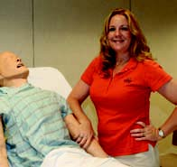specialist, trained at the Peter M. Winter Institute for Simulation Education and Research in Pittsburgh, Pa. Thanks to a grant by the Sam Viersen Family Foundation, OSUIT is receiving a SimMan 3G, an extremely advanced simulator capable of mimicking a wide-range of human responses.
G.I. Jobs Magazine named OSU-Stillwater and OSU-Oklahoma City as Military Friendly Schools for 2010. The two campuses ranked in the magazine’s top 15 percent of colleges and trade schools nationwide who are doing the most to embrace America’s military and veterans as students. The campuses received plaques and are featured in the magazine’s Guide to Military Friendly Schools this month.
OSUIT held two graduation ceremonies for the summer semester on Aug. 21 for more than 300 students. Ceremonies were divided into graduates from the Automotive and HEVi Technologies programs and graduates from all the other programs on campus. Guest speaker for both ceremonies was Houston Davis, vice chancellor for Academic Affairs for the Oklahoma State Regents for Higher Education.
Janet Cole, ornamental horticulture professor, was named a Fellow by the American Society for Horticultural Science at its meeting in St. Louis. She directs one of only six four-year accredited landscape-contracting programs in the U.S.
Alastair Watson, physiological sciences professor, gave a presentation on Chinese white dolphins at the Symposium on the Conservation Strategies for Sousa chinensis in Taipei, Taiwan.
R. Russell Rhinehart, chemical engineering professor and AMOCO Chair, will receive the International Society of Automation’s Distinguished Society Service Award in October in Houston for outstanding service and contributions to the society.
OSU-OKC’s Development Office report that funds raised have increased from an average of $183,000 a year to $381,000 in 2009 – a 108 percent increase in giving.
The first annual appeal for OSU-OKC was
held in May and yielded 63 new donors.
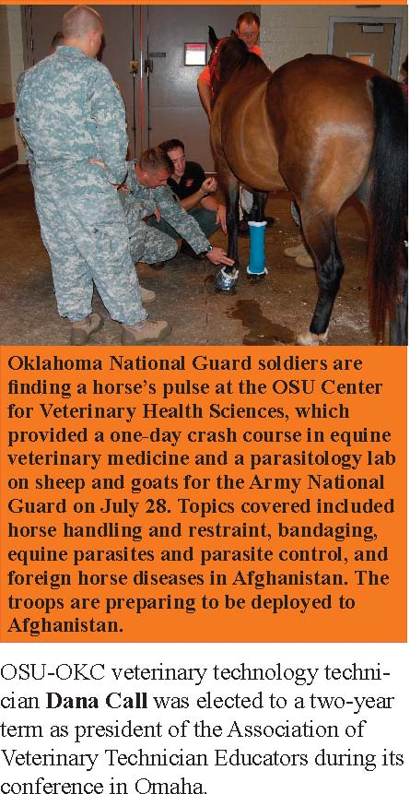
For the third straight year, the Osher Foundation is supporting the Osher Lifelong Learning Institute at OSU with a $100,000 grant.
OSU Center for Veterinary Health Sciences 2009 Distinguished Alumni Award recipients will be James W. Carpenter, ’74, Kansas State University; Anthony W. Confer, ’72, OSU; Robert S. Hudson, ’55, Auburn University; and Gary L. White, ’68, OU Health Sciences Center. Gary Meek, Oscar S. Gellein/Deloitte & Touche professor of accounting, received the Outstanding Service Award from the International Accounting Section of the American Accounting Association at its annual meeting in New York City on Aug. 3.
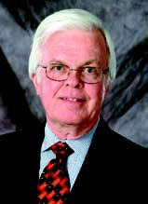
Carey Pope, physiological sciences head and Sitlington Chair in Toxicology, was appointed to the editorial board for
Archives of Toxicology, the official journal
of the European Society of Toxicology. He serves on the editorial board of nine toxi
cology-related scientific journals, and is an
associate editor for the Journal of Pharmacology and Therapeutics.
The Spears School of Business recognized 18 faculty members for excellence in research with the Richard W. Poole Research Excellence Award, presented to faculty members with research accepted and published in top-tier research journals. This year’s recipients are Todd Arnold, Federico Aime, Scott Johnson, Karen Flaherty-Pappas, John Mowen, Kevin Voss, Dave Biros, Rick Wilson, Tom Brown, Alex Zablah, Antonio Camara, Robert Comell, JinKyu Lee, Zane Quible, Ramesh Rao, Nicholas Romano, Betty Simkins and Craig Wallace.
Chad Landgraf was re-elected president of the OSU-CHS Staff Advisory Council and Dennis Adams was reelected vice president. Dallis Graham is secretary and Vicky Pace is treasurer. Puni Jeyasingh, zoology assistant professor, along with an OU colleague, received a $780,000 grant from the National Science Foundation to examine the effects of long-term pollution on lake ecosystems and how it impacts the livelihood of organisms that inhabit them.
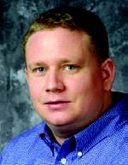

Alumni to Award Six Distinguished Awards

Six individuals will receive the OSU Alumni Association’s 2009 Distinguished Alumni Award at a public reception on Sept. 12.
Recipients this year are Catherine Ebert Jameson of Davis, Richard Jennings of Houston, David Kyle of Tulsa, Joe Martin of Stillwater, Rixio E. Medina of Houston, and Dennis White of Ninnekah.
Jameson attended OSU from 1967-70 and is the founder and CEO of Jameson Management Inc.
Jennings, ’71, is a professor of preventative medicine and community health at the University of Texas Medical Branch in Galveston, Texas.
Kyle, ’74, spent his career at Oklahoma Natural Gas and its parent company, ONEOK, where he also served as chairman, president and CEO from 2000-08.
Martin, ’75, is owner and operator of Stillwater Hospitality, LLC.
Medina, associate ’76 and bachelor’s ’77, is vice president of Health, Safety, Security, Environmental and Shared Services for CITGO Petroleum Corporation.
White, B.S. ’64 and M.S. ’69, was the senior technical adviser for Elanco Animal Health before retiring in 2001.
Logan, Allen, Wyatt and Cooper, all future Cowboys, are the first all-boy quads born in Tulsa since the 1930s. Their parents are Jennifer Lawson-Newby, human resources coordinator for OSU-Tulsa and OSU-CHS, and her husband, Joe.
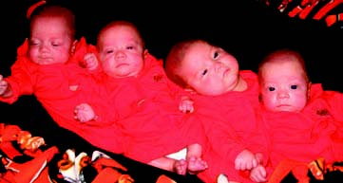

Washington Monthly Ranks OSU High in ‘Public Good’
The Washington Monthly, which rates
schools on their contribution to the pub
lic good, has ranked OSU as No. 128.
The magazine uses categories, such as
social mobility, based on the recruitment
and graduation of low income students,
research producing cutting-edge scholar
ship, and the way students give back to
city and country.
OSU ranked 5th highest among schools in the Big 12.

Brooks Sanders Ventura
Celebrated Trio Headed to Hall of Fame
The OSU Alumni Association will induct three of the most celebrated names in OSU history into the OSU Alumni Hall of Fame: Garth Brooks, Barry Sanders and Robin Ventura.
“The Hall of Fame award recognizes outstanding lifetime achievement in society and professional life and few have reached the heights Garth, Barry and Robin have reached,” said OSU President Burns Hargis. “They have entertained and thrilled millions around the world as well as served their communities. They have made their fellow Cowboys proud.”
Brooks, Sanders and Ventura will serve as Grand Marshals for OSU Homecoming on Oct. 17, and will lead the Sea of Orange Homecoming parade and be recognized during OSU’s football game against Missouri. They also will present the student Homecoming awards.
Brooks, of Owasso, was graduated from OSU in 1984 and is certified by the Recording Industry Association of America as the No. 1 selling solo artist in U.S. history, selling more than 128 million albums and receiving every accolade the recording industry can bestow upon an artist.
Sanders, of Detroit, Mich., is one of
the most electrifying running backs in the history of college and professional football. In 1988 Sanders had the greatest individual season in the history of college football on his way to winning the Heisman Trophy. He set 34 NCAA records in 11 regular season games. After his record junior season at OSU, he joined the Detroit Lions and became one of the most thrilling players in the history of the NFL. He is a member of both the Pro Football Hall of Fame and College Football Hall of Fame.
Ventura, of Santa Maria, Calif., was one of college baseball’s greatest players and an All-Star major league third baseman. He had a remarkable three-year run at OSU from 1986-88. Baseball America named him Player of the Decade, the starting third baseman on its all-time team, and he was third in its Player of the Century poll. He was elected into the inaugural class of the College Baseball Hall of Fame in 2006. He was drafted by the Chicago White Sox following his junior year and spent 16 seasons with the White Sox, New York Mets and New York Yankees. He was a Gold Glove winner and All Star.
Recent CEAT Grads Win International Contest
OSU graduates Aleisha McCabe, Grant
McCool and Derek Sumner won first place
with their design for a chemical facility that would produce methanol from coal in the SNC-Lavalin International Design Competition at the 8th World Congress of Chemical Engineering in Montreal.
The team won the right to represent
the U.S. by placing first in the American
Institute of Chemical Engineers National Student Design Competition in 2008.
The AIChE competition is open to all 160 chemical engineering departments in the country. In the 14 years of the competition, OSU students have placed first five times, while no other university has won more than twice.
McCabe is now an applications engineer for Zeeco in Tulsa; McCool is a plant engineer for Linde BOC Process Plants in Tulsa; and Sumner is a production engineer for ConocoPhillips in Sweeney, Tex.
Sumner, McCabe and McCool
Prior to seeing the Cowboys win their season opener against Georgia, a huge crowd of fans were on hand for the
dedication and ribbon cutting that officially opened Boone
Pickens Stadium on Sept. 5. And for the second time in a month, OSU is on the cover of Sports Illustrated.
More than 1,400 new students gathered on the library lawn with President Burns Hargis and his wife, Ann, for an ALPHA group photo. ALPHA registration closed early this year due to the large student response. The three-day experience helps freshmen make friends, learn their way around campus, and kick off the new school year.
The first tracheal stent placement in a dog at OSU’s Veterinary Medical Teaching Hos-pital can been seen in the X-ray.
Returning OSU-Tulsa students watched the planting of more than 300 campus trees.
Dean Michael Lorenz, center, and other officials with the OSU Center for Veterinary Health Sciences, welcomed the 82 freshmen in the Class of 2013 during the traditional White Coat
Ceremony.
Logan, Allen, Wyatt and Cooper, all future Cowboys, are the first all-boy quads born in Tulsa since the 1930s. Their parents are Jennifer Lawson-Newby, human resources coordinator for OSU-Tulsa and OSU-CHS, and her husband, Joe.
Sumner, McCabe and McCool
